  

**Guidance Document for Applicants**

INSTRUCTIONS FOR FILLING APPICATION FORM

**Table of Contents**

1. **User Registration**
2. **Register to Multifactor Authentication (MFA)**
3. **Login as Existing User**
4. **Application Form Filling Workflow**
5. **Reset Passcode**

**1: User Registration**

### **1.1 New User Creation**

* **Action:** Applicant fills in registration details.

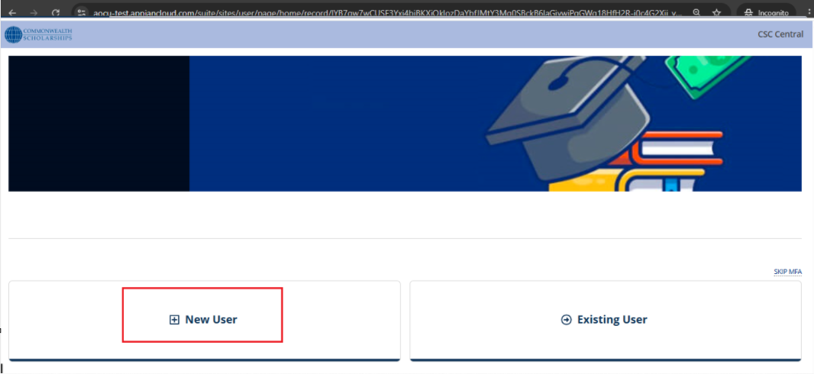

* **Trigger:** Clicks **Submit**.

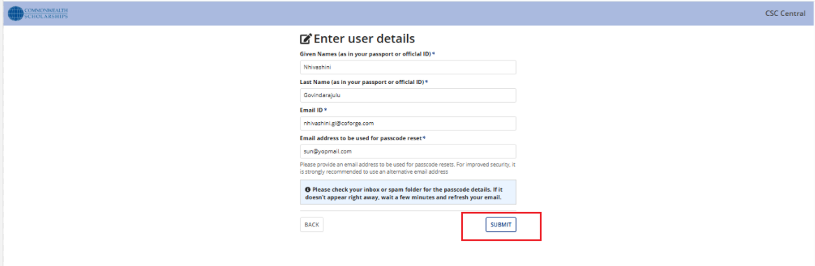

* **System Response:** Sends an **email with a passcode** to the applicant.

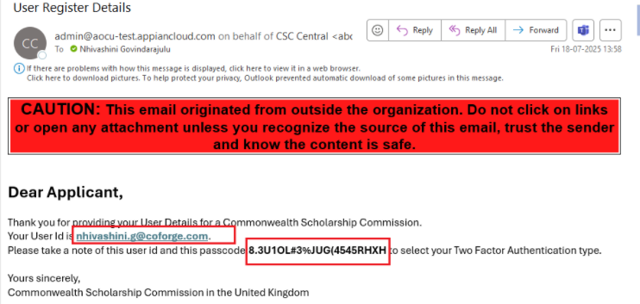

## **2: Register to MultiFactor Autentication(MFA)**

## **2.1 Login Process**

* **Action:** click on ‘Register ‘MultiFactor Autentication’ button

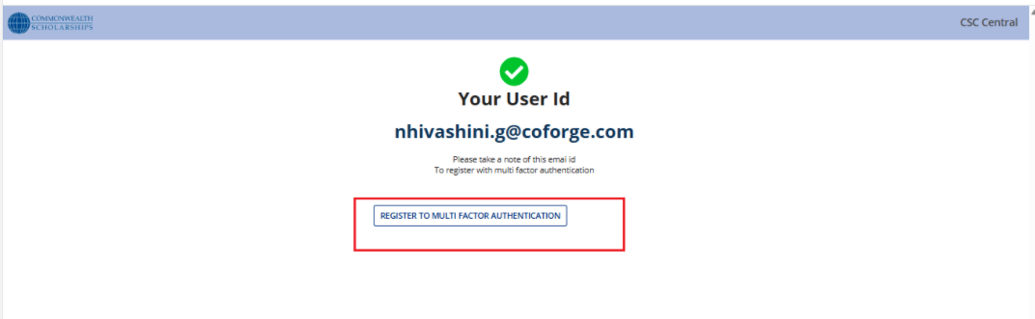

* **Input:** Registered **email ID** and **passcode**.

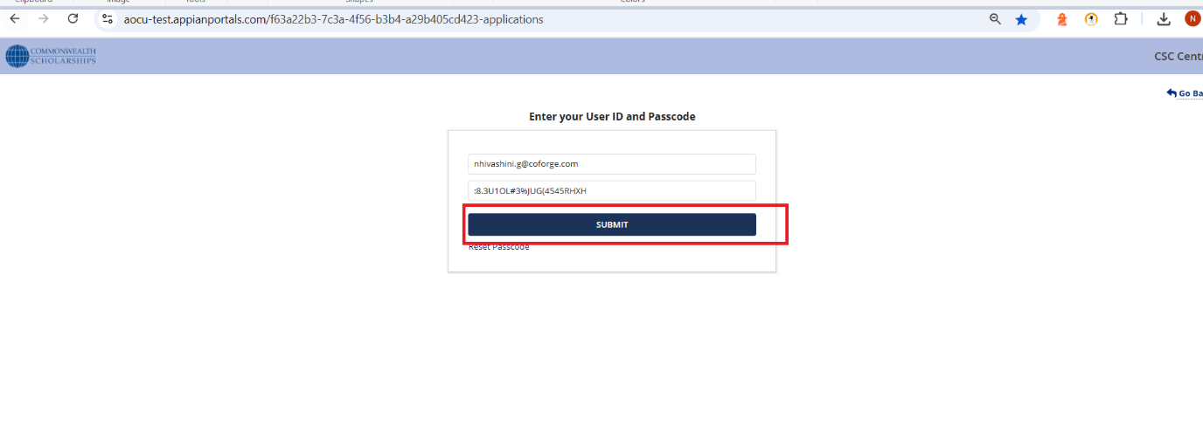

* **Next Step:** Proceeds to **Multifactor Authentication (MFA)**.

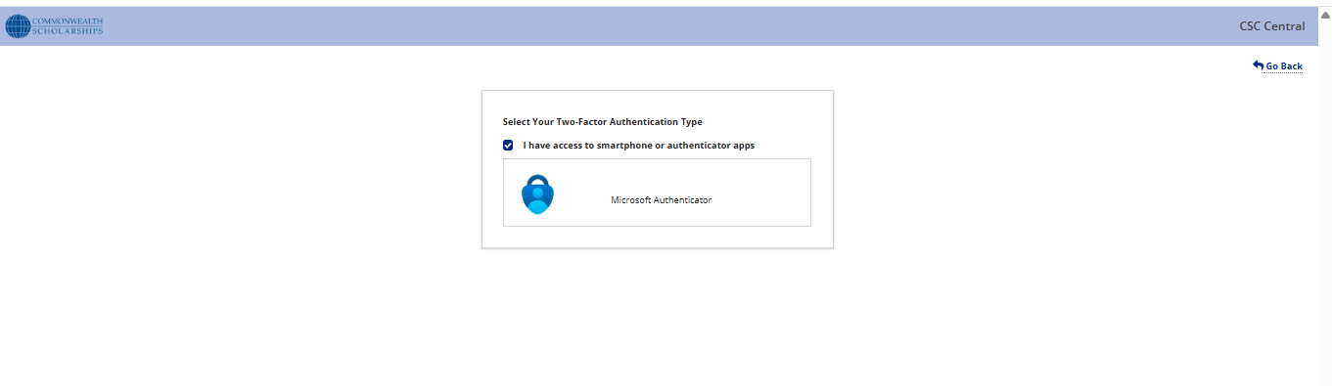

## **2.2. Multifactor Authentication (MFA)**

### **2.1.1. Type: Email**

1. Deselect the checkbox.

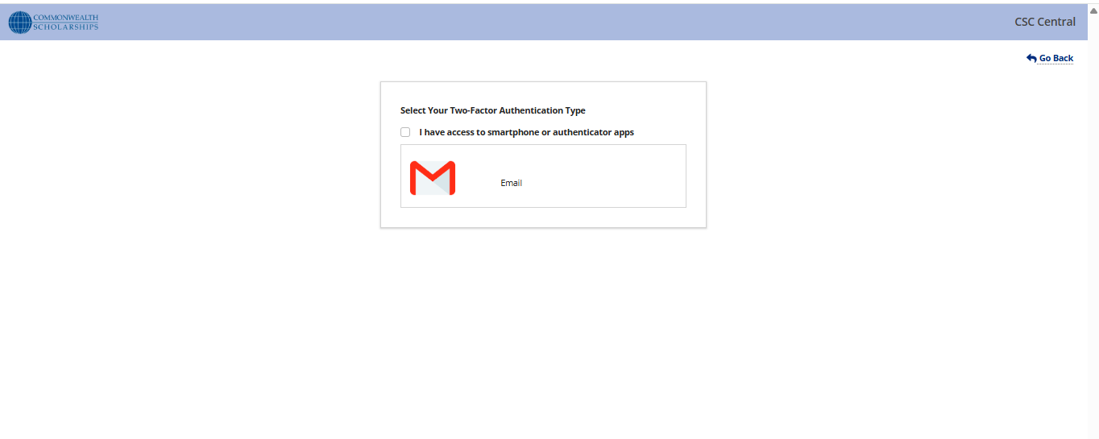

1. Click on ‘Email’ button
2. Click on ‘Generate OTP’ button

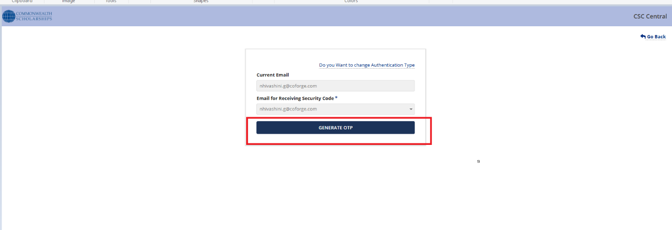

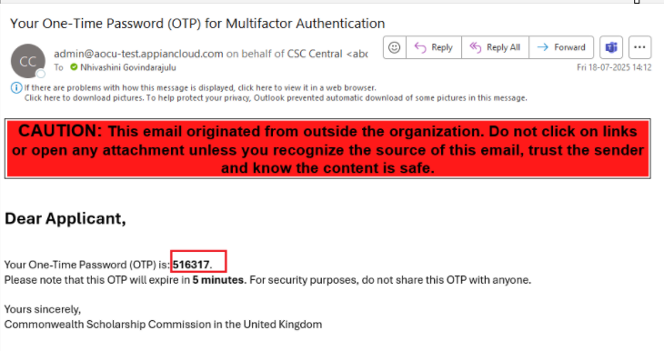

1. Click **Verify OTP**.

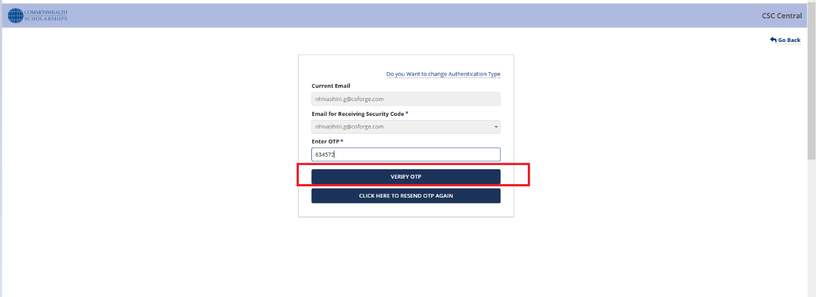

1. Click **REGISTER**.

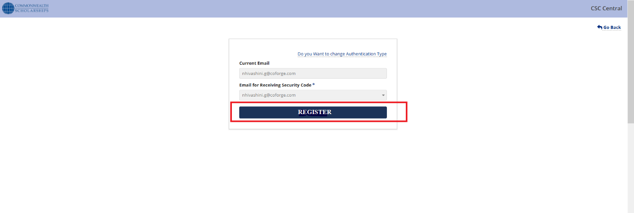

1. **System Response:** Display **"Registration Completed"** confirmation message.

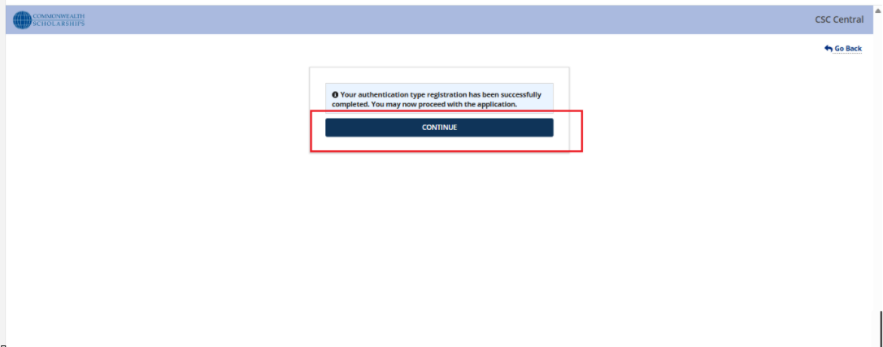

**2.1.2. Type: Authenticator App**

1. Select **Microsoft Authenticator** option.



1. Scan **QR code** using an authenticator app.

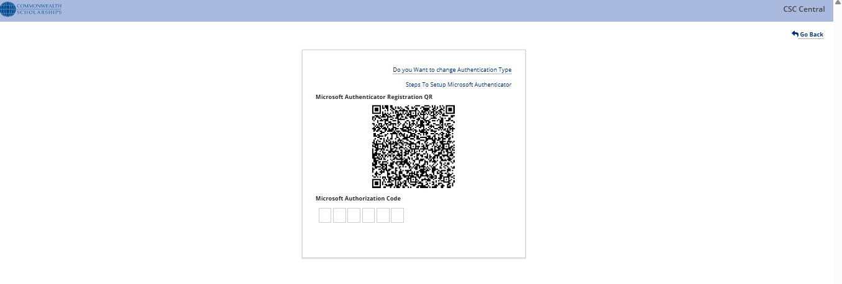

1. Enter the code from the app.

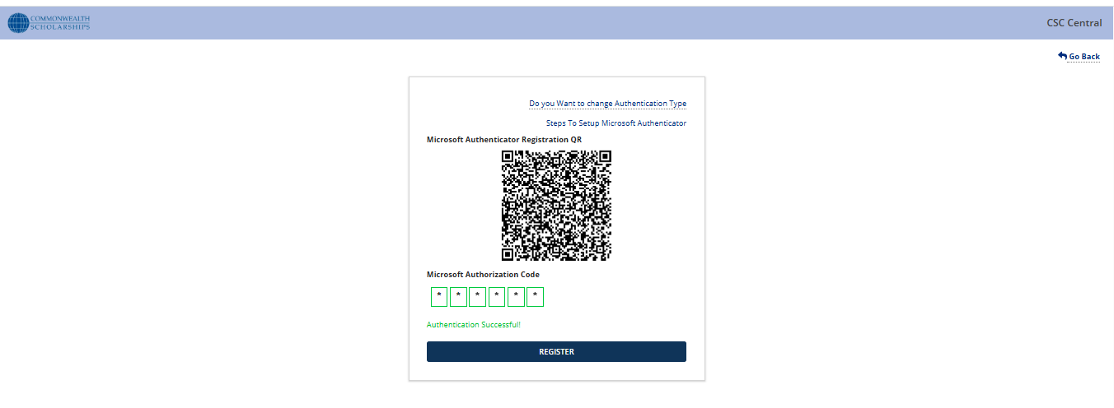

1. Click **Register**.
2. **System Response:** Display **"Registration Completed"** confirmation message.

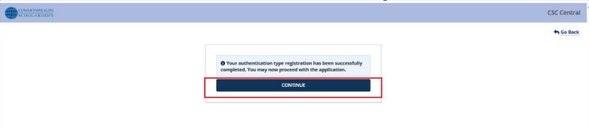**3. Login as Existing User**

### **3.1 Login Process**

**1. Action:** Applicant selects **Existing User**.

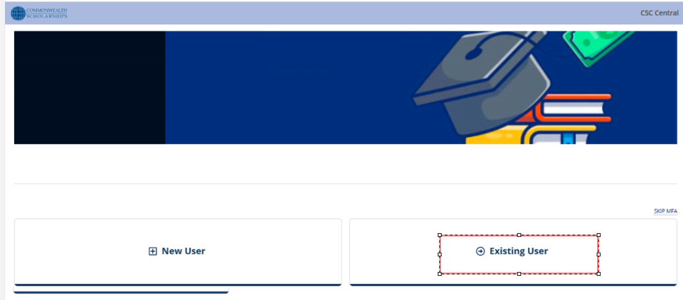

**2. Input:** Registered **email ID** and **passcode**.

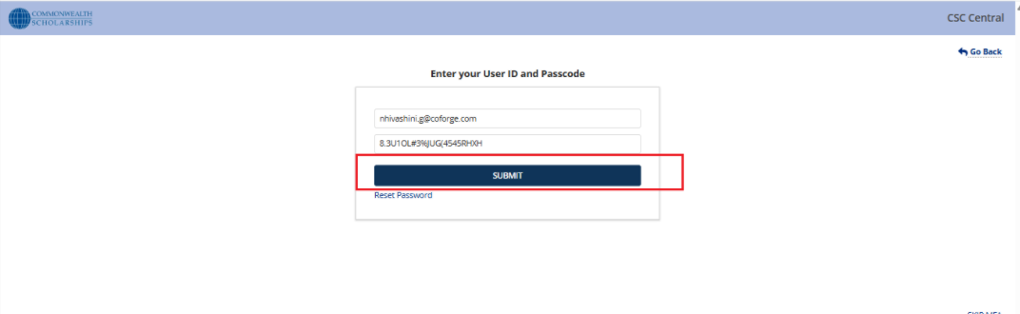

**3. Next Step:** Proceeds to **Multifactor Authentication (MFA)**.

**3.1.1** Once registered using the Authenticator App, the OTP Verification screen is displayed. Enter the code from your linked device to complete authentication.

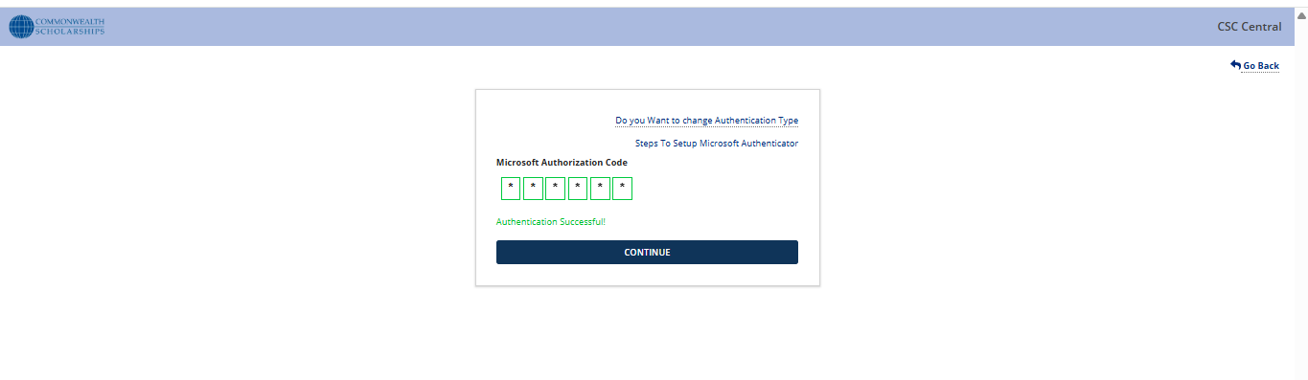**3.1.2** Registered with an email, the Email Verification screen is displayed. Enter the new code and click 'Verify OTP' -> ’Continue’ button to login to Landing page of portal



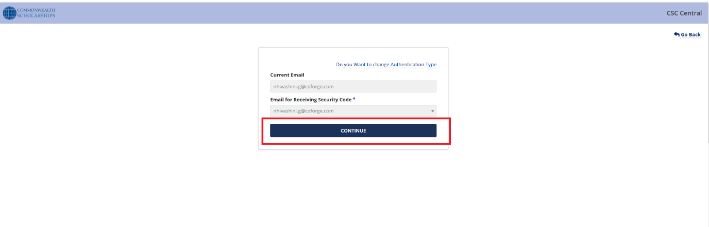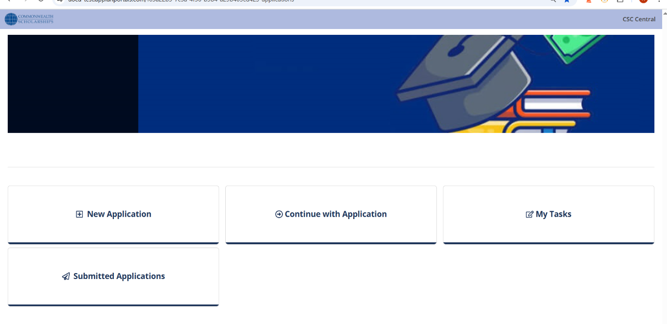

## **4. Application Form Filling Workflow**

### **4.1 New Application**

**4.1.1. Start Application**

* Applicant initiates a new application process.

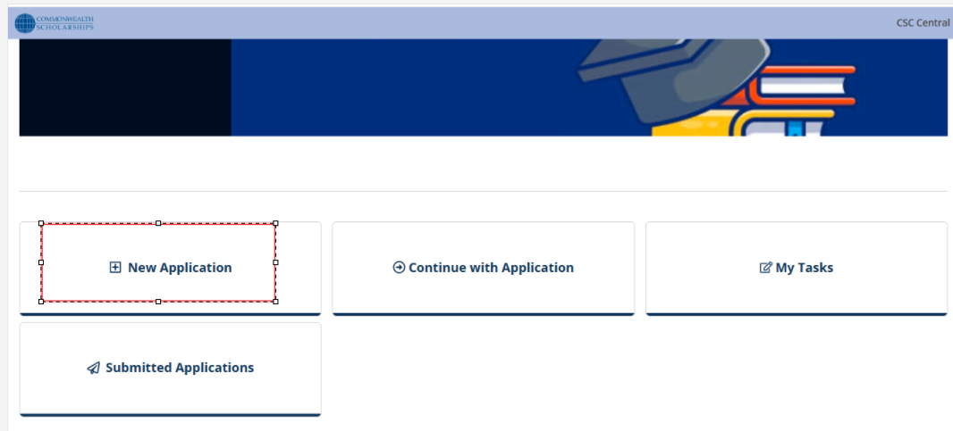**4.1.2. Enter Access Details**

* Applicant Fills required identification details.

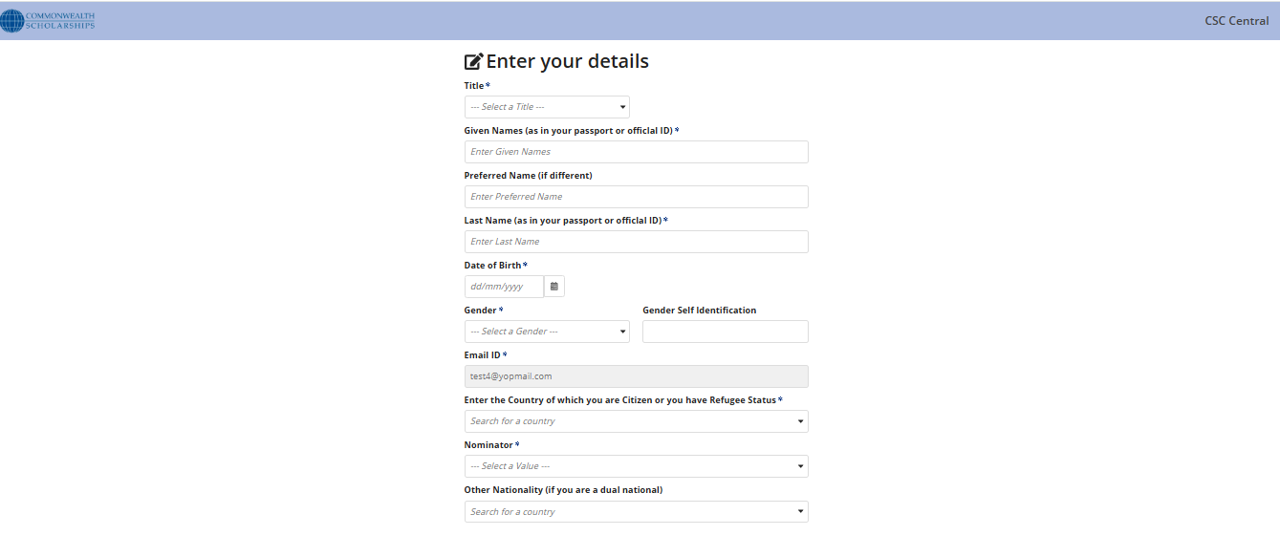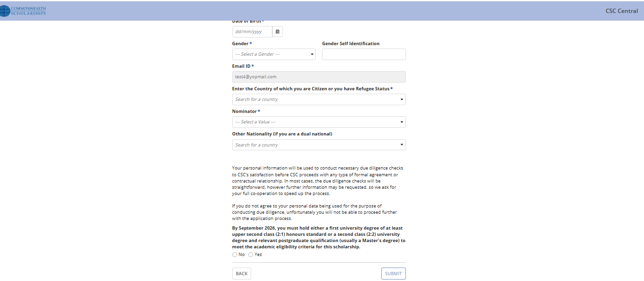

### **4.1.3. Reference Number Generation**

* As an applicant ‘**Submits’ Access details**, System generates a unique reference number for the application.

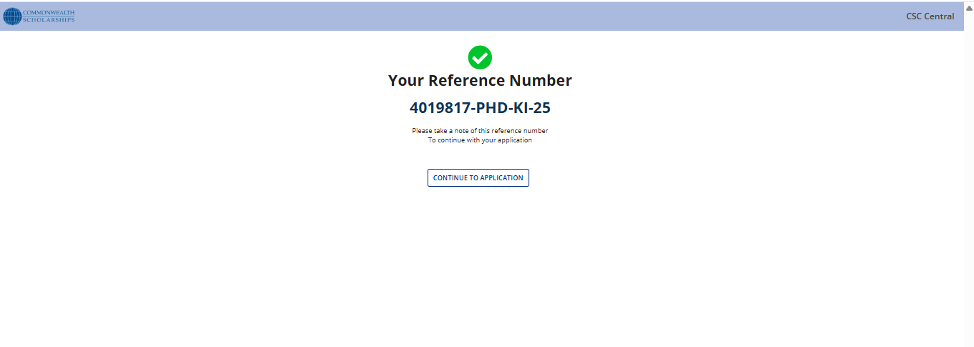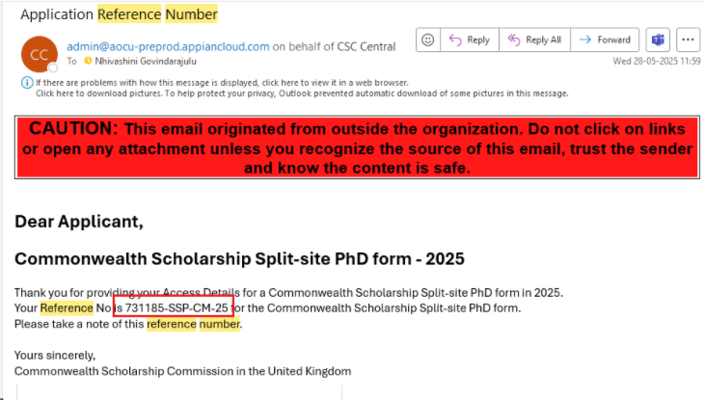

### **4.1.4. Fill Application Form**

* As an applicant when clicking on **‘Continue To Application’**, Applicant completes all required fields in the application form.

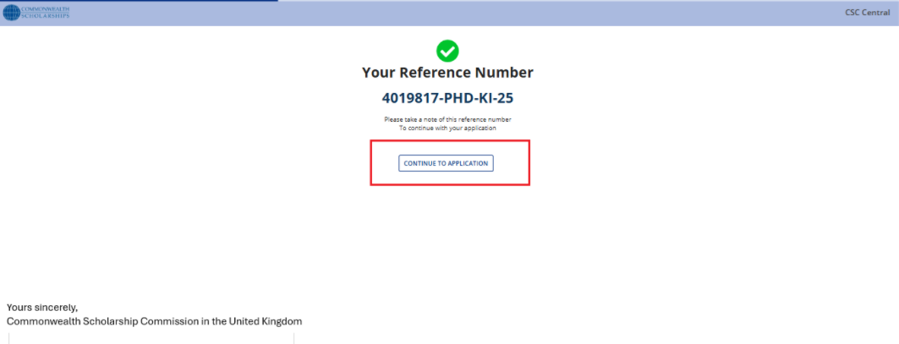

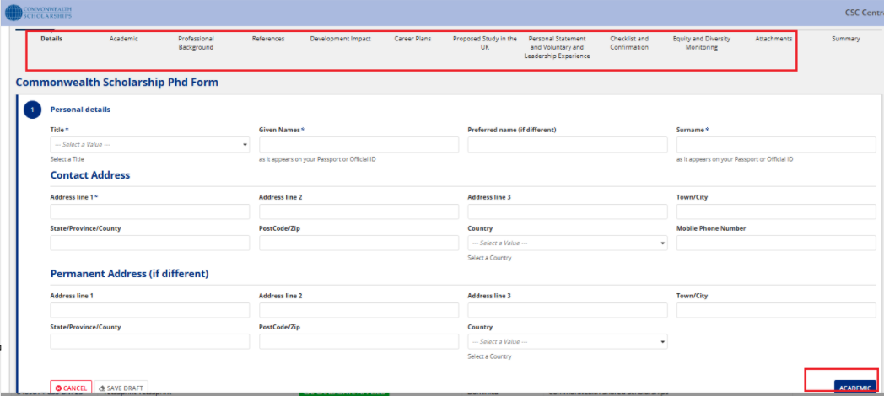

### **4.1.5. Preview Summary**

* As an Applicant reviews a summary of the entered information for accuracy.

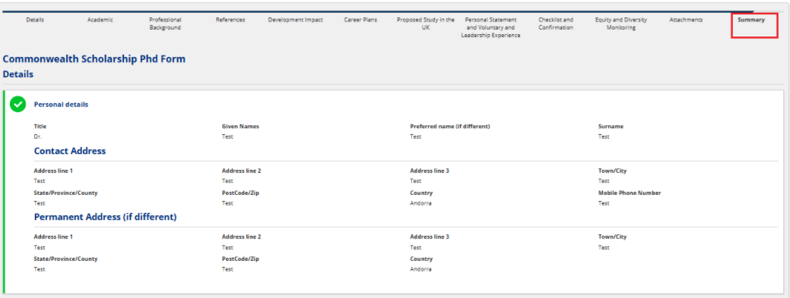

### **4.1.6. Submit to CSC Team**

* As an Applicant’s clicking on **‘Submit’** button, finalized application is submitted to the CSC Team for processing.

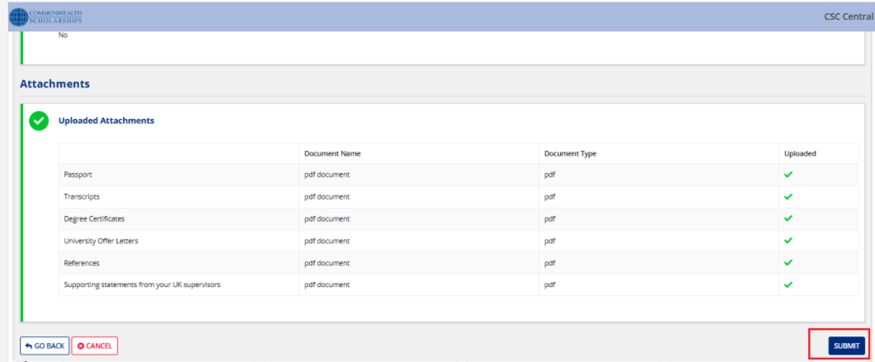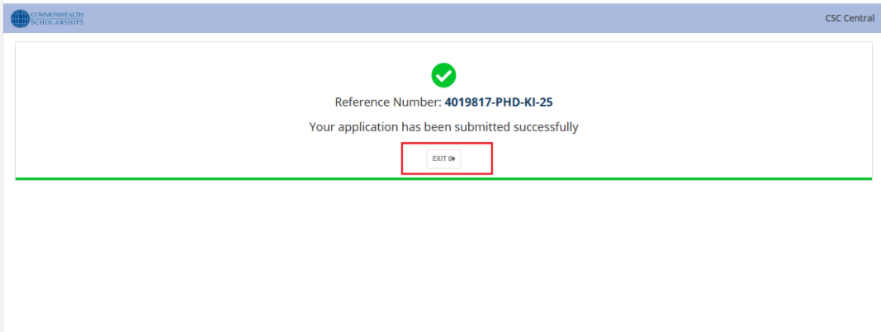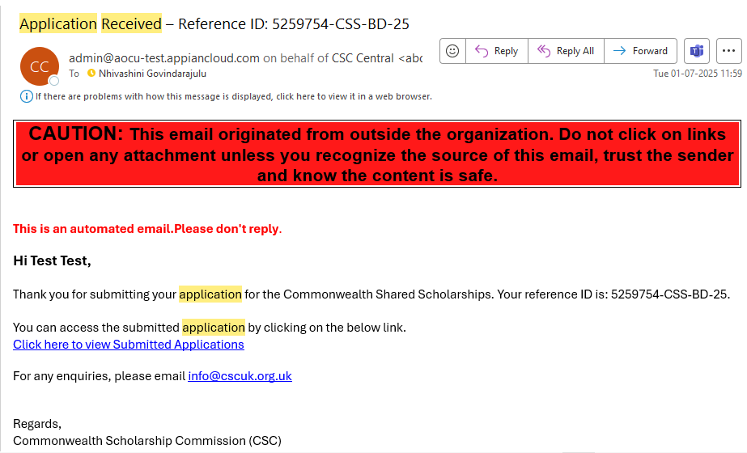

### **4.2 Continue with Application**

* As an applicant, clicking on ‘**Save Draft**’, Applicant resumes a **previously saved** application.

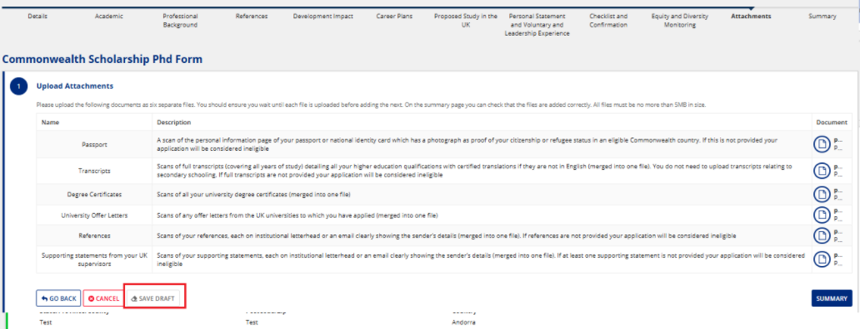

As an applicant, clicking on ’**Go To Home Page**’, Landing page is displayed

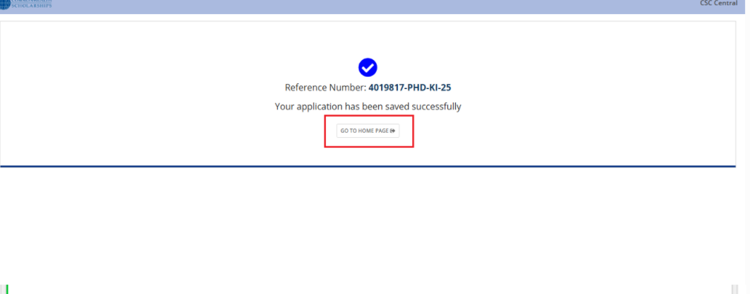As an applicant, clicking on ’**Continue with Application**’ card, Search by Reference Number/Search by Email ID screen is displayed.

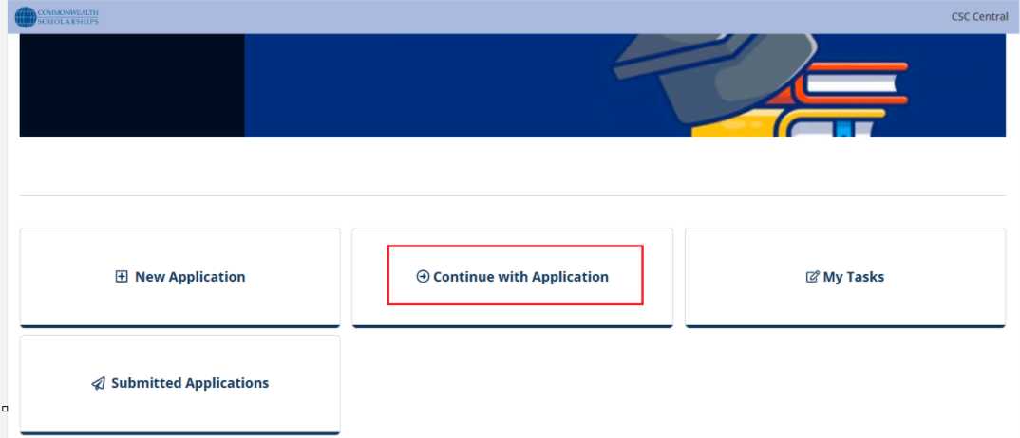

As an applicant, clicking on ‘**Continue with Reference Number’**, Enter your Reference number screen is displayed.

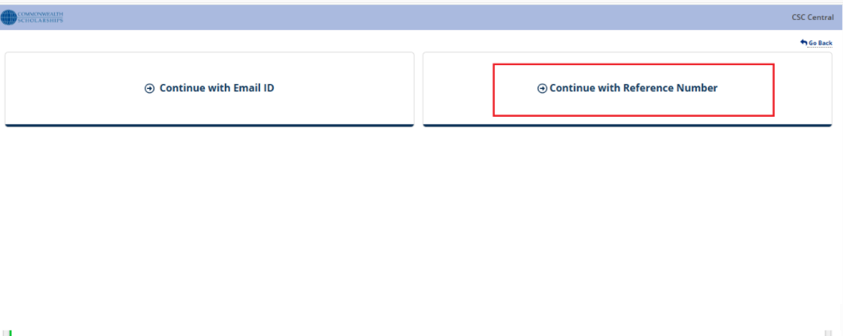

As an Applicant E**nter the Reference Number**

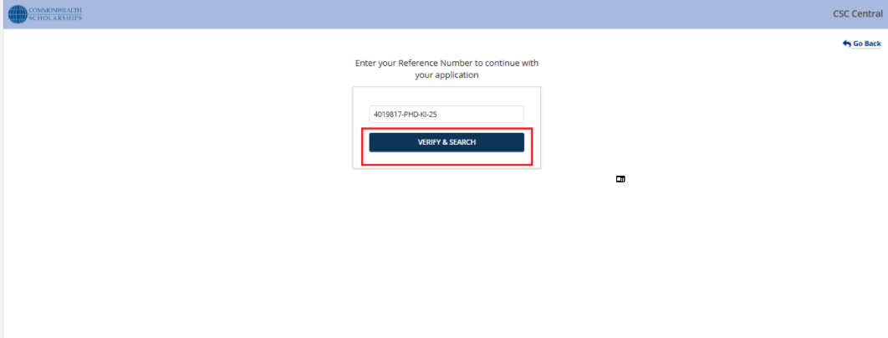As an applicant, clicking on ’**Verify & Search**’ applicant can resume the application

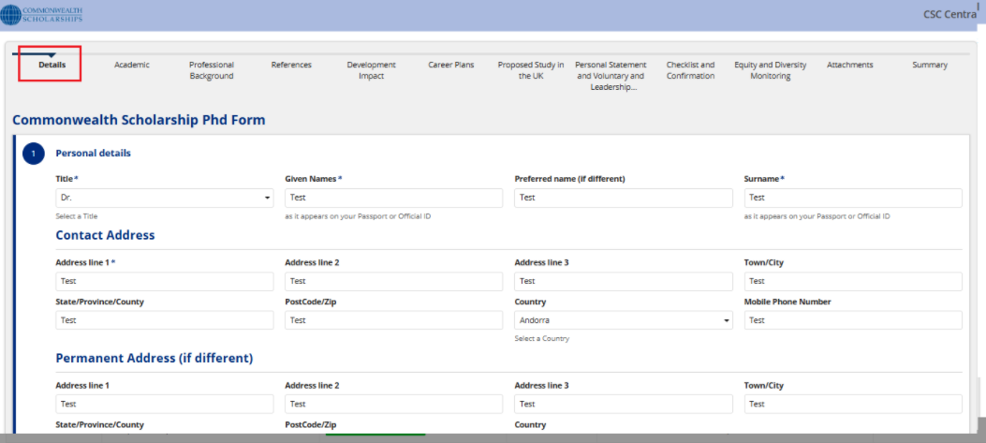

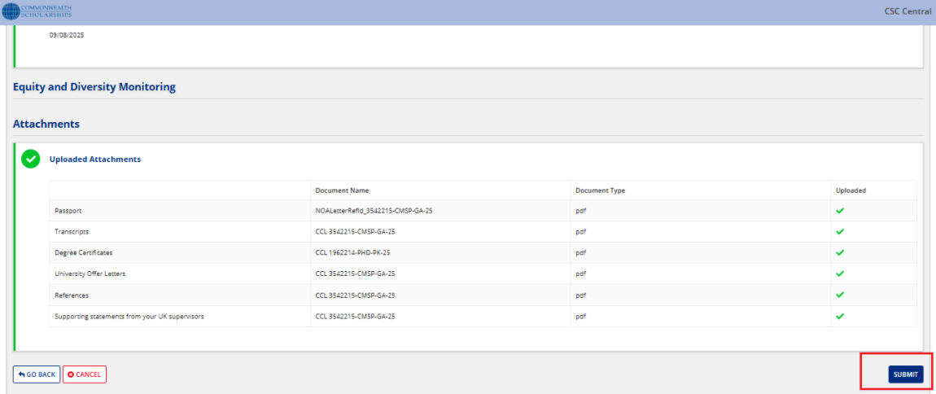

### **4.3 Submitted Application**

* As an applicant, clicking on '**Submitted Applications**’ in Landing page

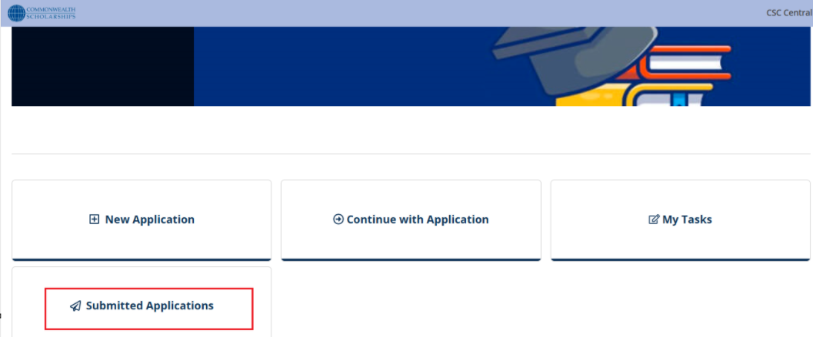As an Applicant E**nter the Reference Number**

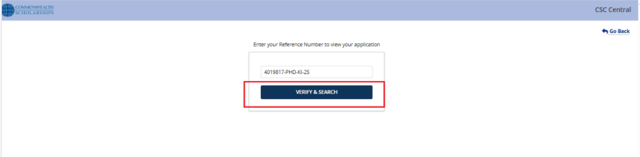

As an Applicant clicking on ‘**Verify and Search**’, Applicant views a **submitted application**.

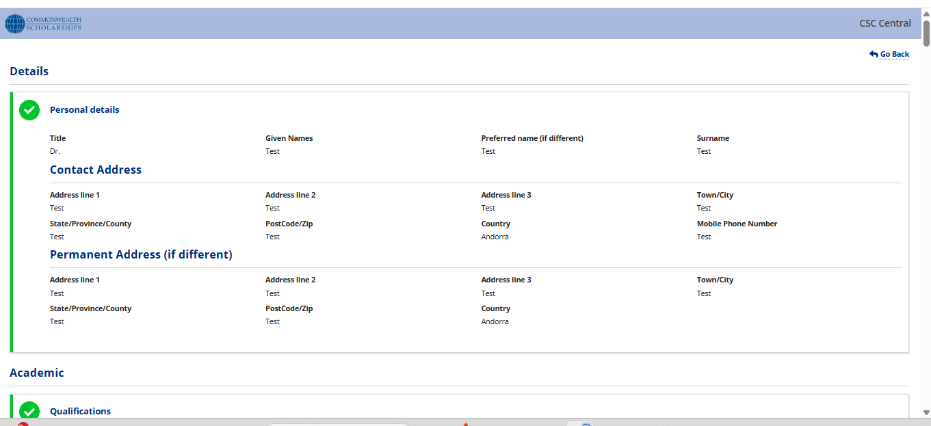

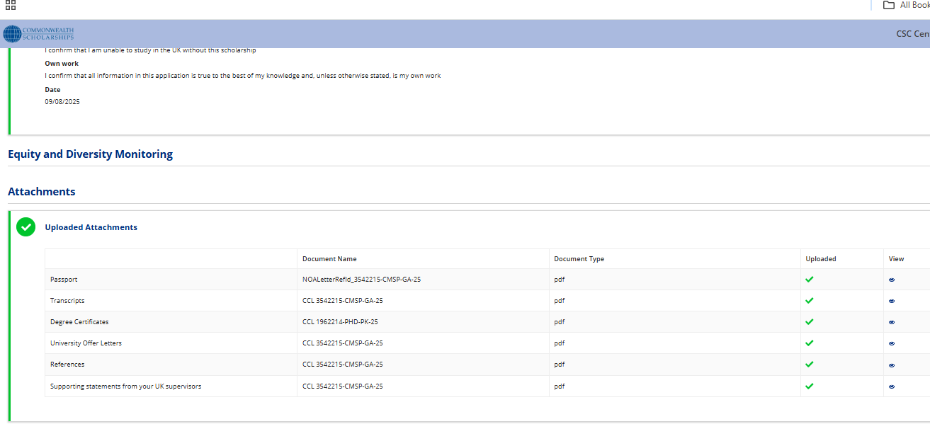

### **4.4 My Tasks**

1. **Click on ‘My Task’ Card**  
   The applicant accesses the portal and selects the **"My Task"** section to view pending actions.

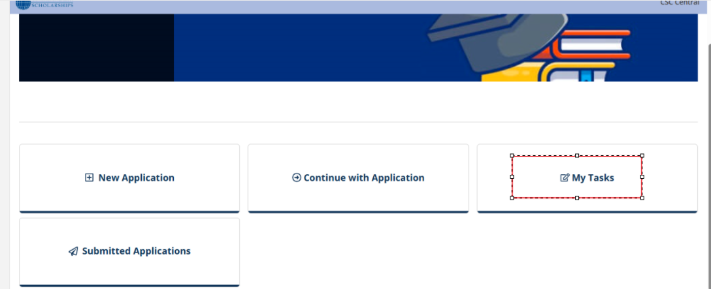

1. **Enter Email and Reference Number**  
   A form appears prompting the applicant to input:
   1. **Email ID** (used for identification)
   2. **Reference Number** (unique to their application)

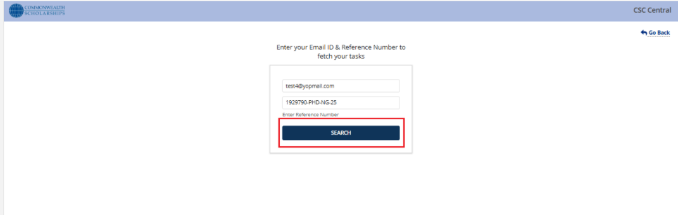

1. **Click ‘Search’**  
   After entering the details, the applicant clicks the **"Search"** button.

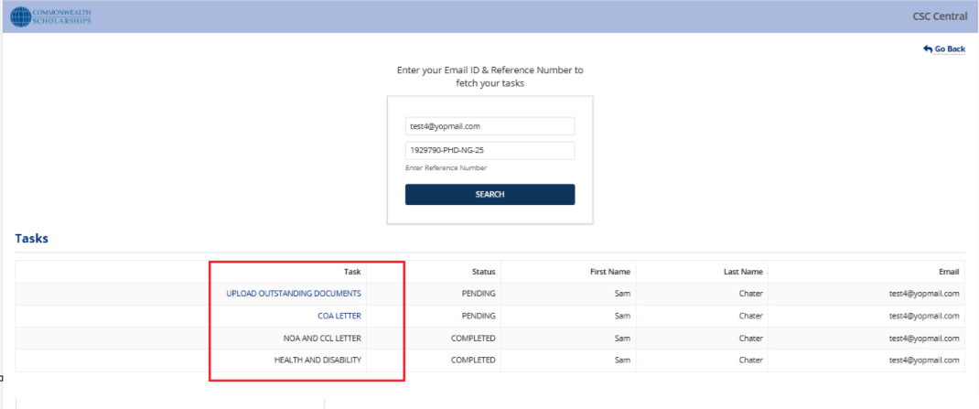

1. **View and Complete Pending Task**  
   The system retrieves any **pending tasks** associated with the provided credentials.  
   The applicant can then:
   1. View the task details
   2. Upload documents/ fill forms, or complete assessments
   3. Submit the task to proceed in the **Selection Process**

**Note:**

Below is the email sent to scholars, prompting them to complete their pending tasks as part of the selection process

**Provisional Email to Scholar**

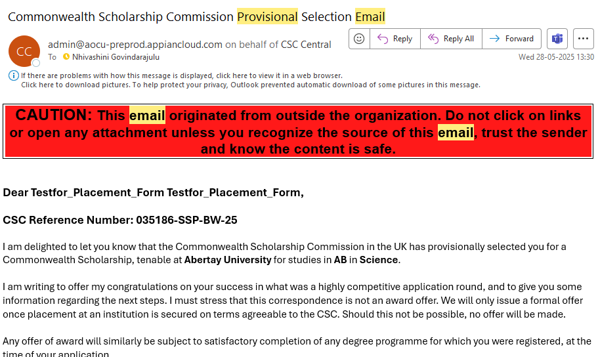

Notification of Award to Scholar

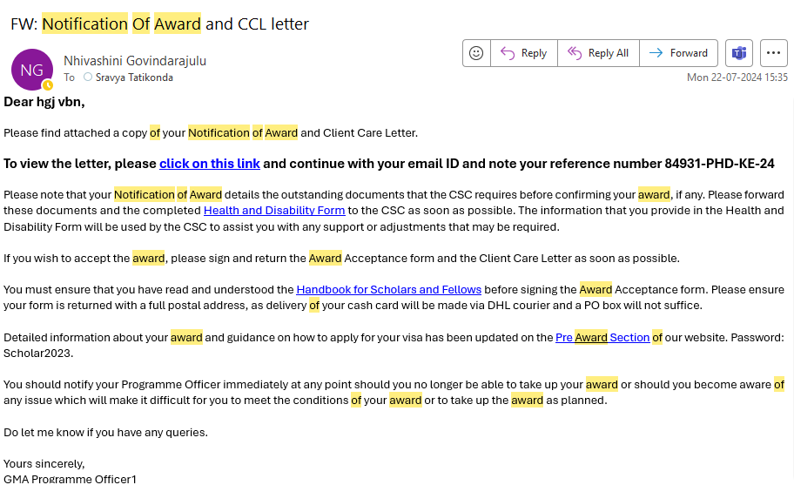

Confirmation of Award to Scholar

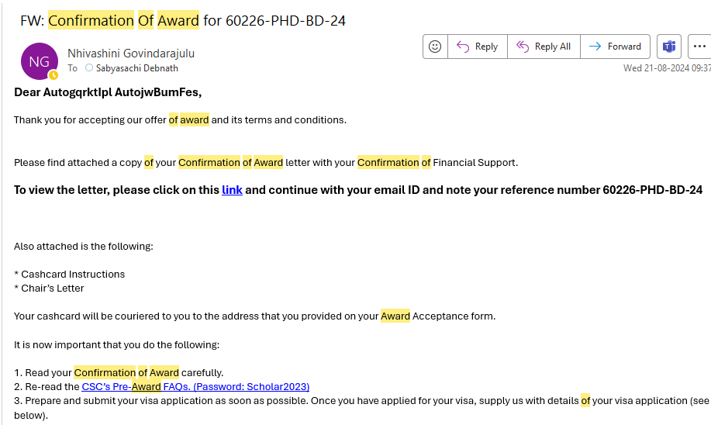

1. **Reset Passcode**

As a Scholar, you can reset your passcode using the following steps:

1. In the landing page, Click on the "**Existing User**" tab.
2. Click on the "**Reset Passcode**" link.

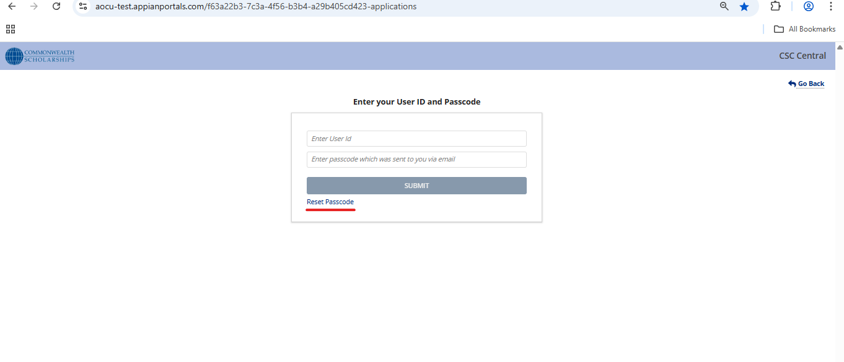

1. Enter your registered email address.
2. Click the "**Validate**" button.

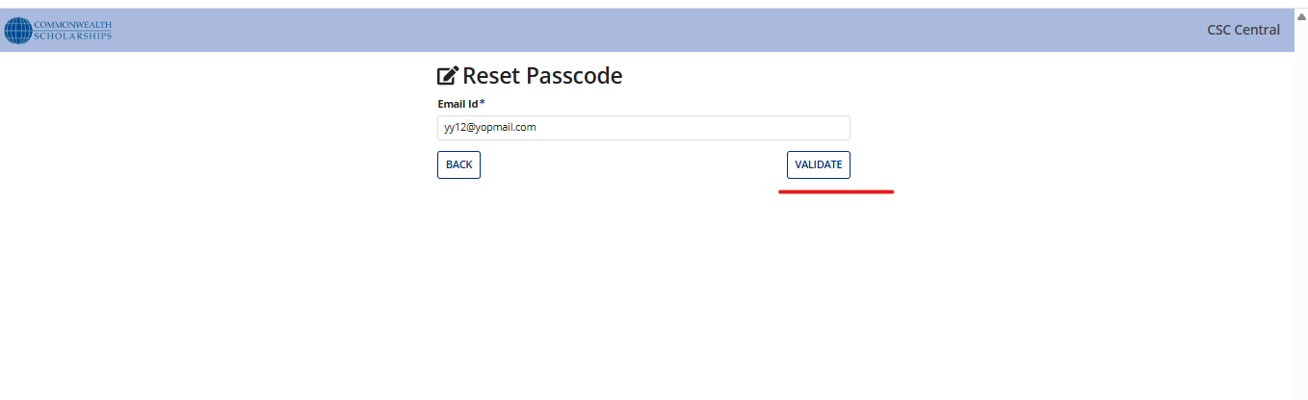

1. Click the "**Send** **OTP**" button to receive a secure One-Time Passcode via email.

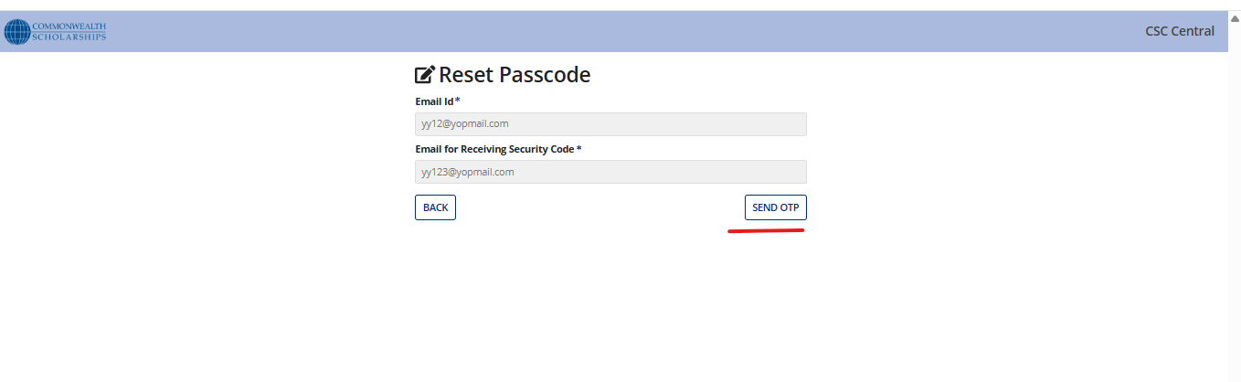

1. **Receive a secure One-Time Passcode (OTP)** sent to your selected email (Secondary).

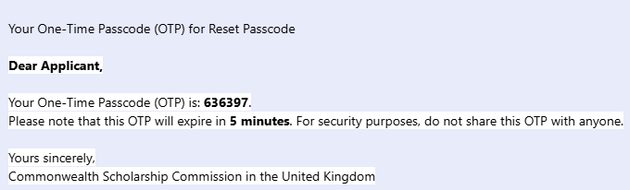

1. **Use the OTP to reset your passcode** and regain access to your account.

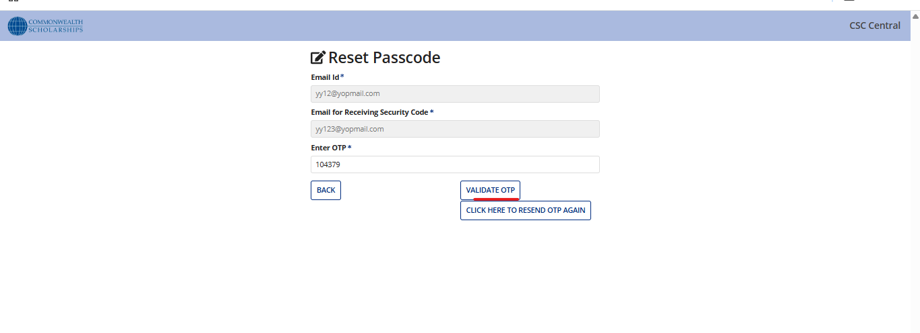

When selecting either your **Primary** or **Secondary** email address, the passcode reset email will be sent to that address. You can then log in as an existing user using the new passcode.

