CSC workshop 1 – pre workshop activities

Your name:

Task 1: The change you would like to see

Prepare a brief statement (not more than 25 words) of one specific change you would like to see happen as a result of your CSC-funded research within the next 2 years

Task 2: Stakeholder analysis
Do an initial stakeholder analysis of the 10-15 key people/organisations who you need to engage with to achieve this. You could use the importance/influence matrix introduced in week 4 of your CSC MOOC (key on next page):

Group 1: High importance / low influence  [enter text here] | Group 2: High importance / high influence
Group 3: Low importance / low influence | Group 4: Low importance / high influence

Key:
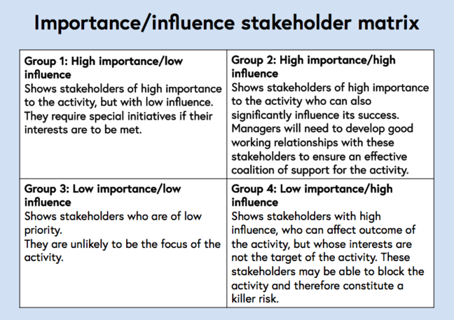
© _{MFAR ©iceida ©UNU-FTP}

