Applying for a Student Visa

Step by Step Guide
Congratulations on your CSC Scholarship award!
We’ve put together a step by step guide to help you complete your Student Visa application form. Please make sure you read Applying for a Student Visa on the CSC website first before you start your visa application. You can also read more in the Home Office’s Student Visa Policy Guidance.
After you have received your CAS (Confirmation of Acceptance of Studies) from your university, and your Confirmation of Award from the CSC, you should apply for your visa by finding the link on the UK Government’s website and the screen below will appear.
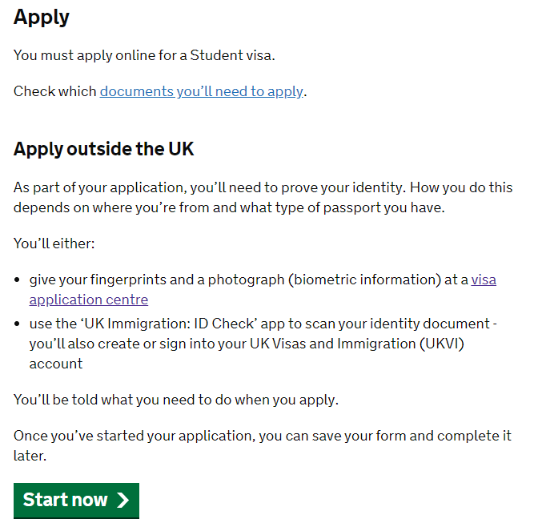
Click here to apply.
Click on the link as shown in the box above to start the application process.
IMPORTANT: You must complete the form fully and accurately. If you deliberately withhold or use false information your current application and any future UK visa applications could be refused.
You will be asked some initial questions to start the application including whether you intend to live in one of the Crown Dependencies of the UK and whether you hold an EU, EEA, or Swiss Passport. If you hold one of these passports with a biometric chip, then you can use the UK Immigration ID Check app. If you do not have one of these passports with a biometric chip then you will need to attend a visa appointment at a visa application centre in your country, or the designated alternative location.
We recommend that you select English as the language which the online visa application system will use for your application.
Make sure that you select the correct visa type for your application. You should select the student visa to come to study in the UK and you should receive a CAS from your university to allow you to do this. If you have been advised to apply for a different type of visa then please contact us at welfare@cscuk.org.uk.

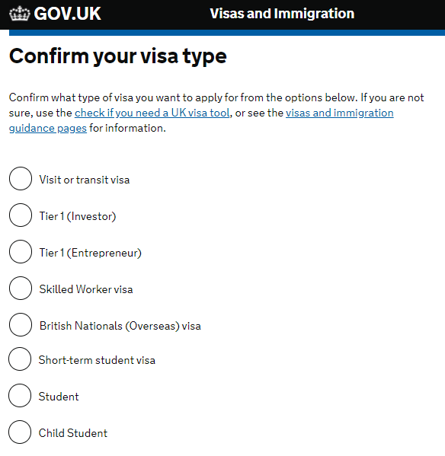
Select this category.

Next, choose the country from where you are making your application.
You should be applying for the visa in the country where you are legally resident. Normally you will be required to submit your biometric data (fingerprints and photograph) at a visa application centre (VAC) in that country. Not all countries will have a VAC and if this is the case for you then you will need to travel to a different country to submit your biometric data. If the country where you are resident does not have a VAC then there will be more information about this on the next page, and so we would recommend that you still enter the country where you are resident on this page.
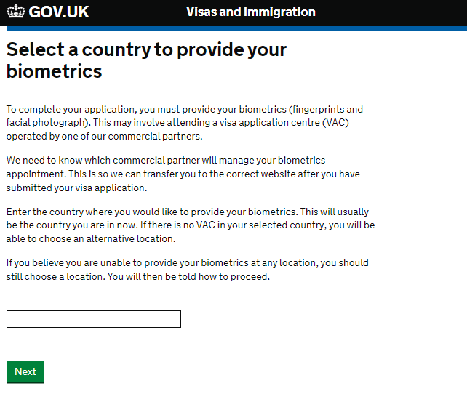
Enter your country here

On the following screen you will be asked to confirm that you are able to attend an appointment at a visa application centre in your country or the appropriate designated country.
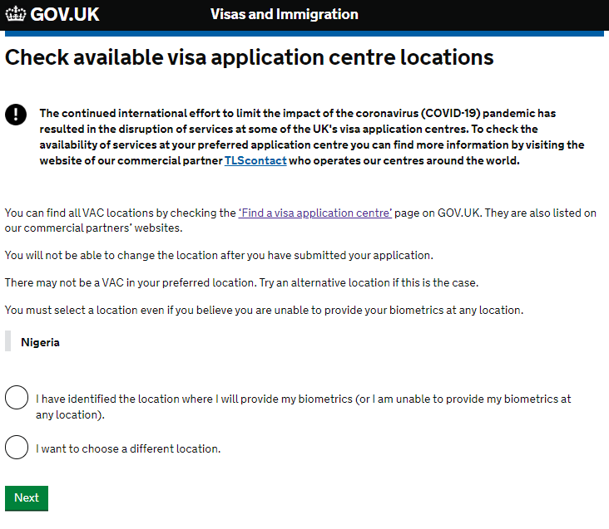
Click here to check VAC availability.

Clicking the link highlighted above will take you to a page with links to information about the visa application centres in your country. If there is no visa application centre in your country this page will tell you where you will need to travel to attend your visa appointment.
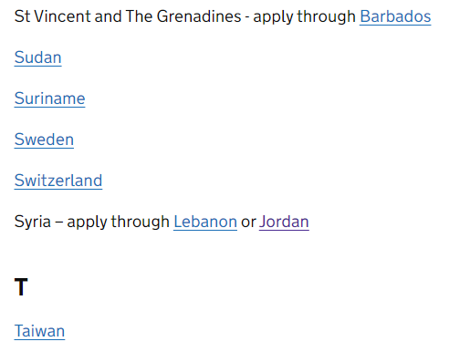
Example: If you are from Saint Vincent and the Grenadines you will need to attend your visa appointment in Barbados. Click on the link here for Barbados to find out more about visa appointments there.
Once you confirm that there is a VAC available for you to attend, go back to the main application page and select the option ‘I have identified the location where I will provide my biometrics (or I am unable to provide biometrics at any location’. Then click ‘Next’ to continue.
If you are not able to travel to a location in your selected country, or the nominated redirected country, then you can go back to the initial page (page 3 of this guide) to select a country to provide your biometrics and choose to apply from another country where you have legal residency.
The COVID-19 pandemic has resulted in disruption at some of the UK’s visa application centres around the world. You should check the availability of the services by checking the webpages of the UKVI commercial partners, as shown above.

The next two screens will take you to the start of the online application.
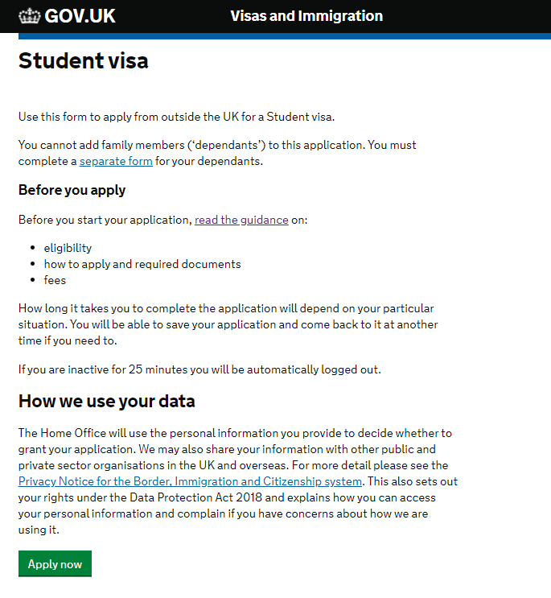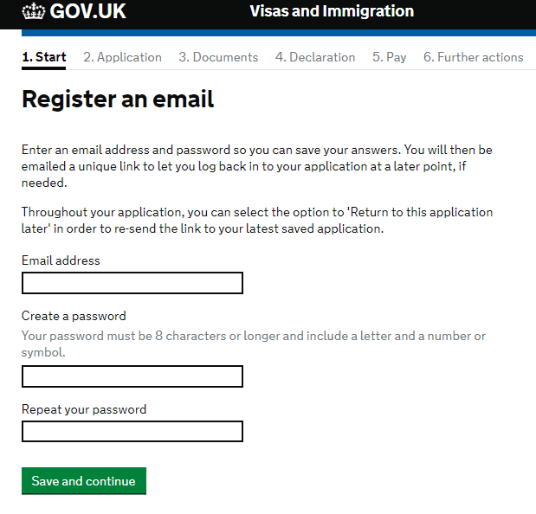
Please note that if you wish to bring dependents (family) to the UK you will need to make separate applications for them. Please see the handbook relevant to your award on our website to see what support the CSC can provide for you and your dependants.
To start a visa application, you will first need to register your e-mail address and create a password. Your application will then be registered with that address, and you will be sent a link for your application.
It is important that you keep this link safe as you will need to use it to come back and finish off any sections of your application if at any point you save and close it.

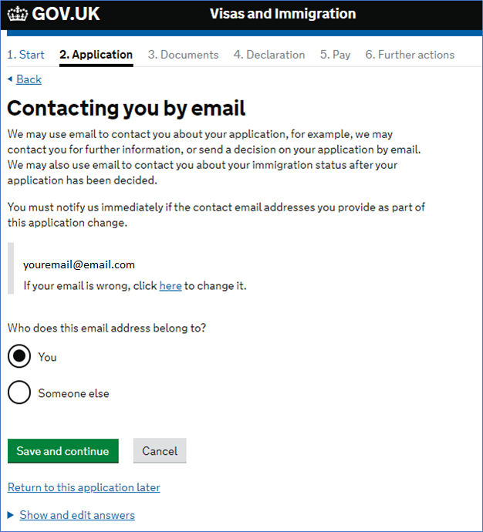
If you wish to save your application and come back to it at any time, then you can click on this link to save and sign out. If you leave the application inactive for 25 minutes you will be automatically signed out and all previous answers will be saved up to but not including the last page that you were on.
You will then be asked to confirm your e-mail address and you will proceed to another screen where you can provide an additional e-mail address.

The next screens will ask you to provide any contact telephone numbers you have as a Home Office caseworker may want to contact you about your application. This is very rare, but it is a good idea to provide a telephone number where you can be contacted if required.
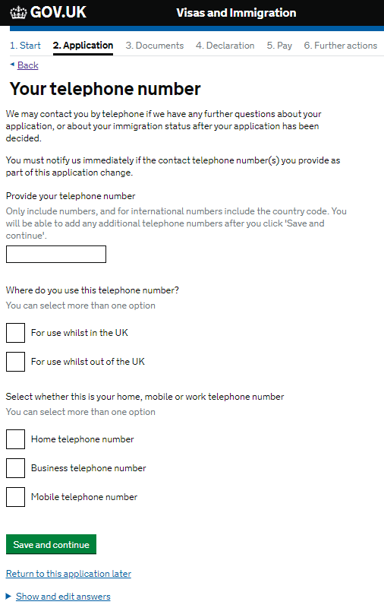
If at any stage throughout your visa application, you would like to review and change your previous answers then you can do this by clicking on this button.
Make sure you include the full international dialling code if you are not providing a UK telephone number.
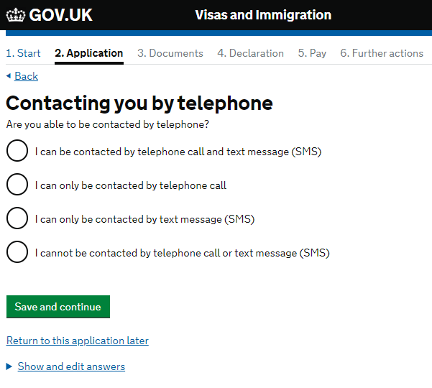
You can provide additional numbers if you have more than one telephone number. Once you have submitted all your telephone numbers you can choose how you would like to be contacted by the Home Office if they need to discuss your application with you.

The following screen is very important as you can confirm that you will be in receipt of a CSC scholarship for the 2022/23 academic year. Selecting ‘Yes’ to this question allows you to bypass any visa fees, including the immigration health surcharge (IHS) at the end of the application process.
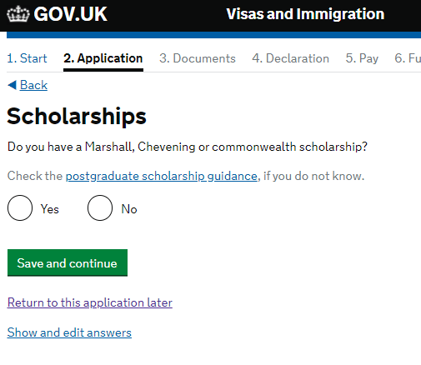

To evidence your CSC Scholarship you will need to submit your Confirmation of Award (COA) at the end of the visa application.

For the next section you will need your CAS (Confirmation of Acceptance of Studies) from your university.
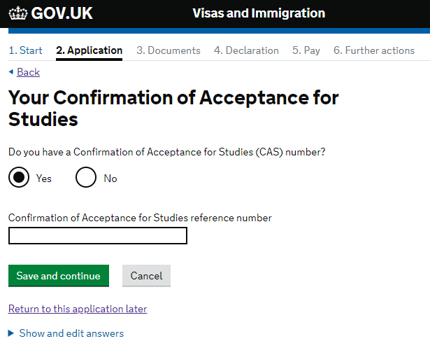
You must have a CAS before submitting your Student Visa application. The CAS is an electronic document issued to you by your chosen university and is valid for six months from the date your university created it
Your CAS should contain the Confirmation of Acceptance for Studies reference number, the details of your university’s Student Sponsor Licence Number, your course details as well as the information from your passport. The name of your sponsor is the name of the university where you will be studying in the UK.
If you submit your visa application without a CAS or the wrong CAS details your visa application will be refused.
You can find out more information about your CAS by visiting the UKCISA website.
IMPORTANT: Your CAS can only be used once. If for any reason you need to submit a new visa application, then you may need a new CAS. If you do need to make a new visa application, please speak to an international student advisor at your university first.

You will need to provide details of your name, as shown in your passport or travel document.
You should be using your personal passport. If you have a diplomatic, military or official passport, you should not be using this for the visa application because a CSC Scholarship is not considered an official posting relevant to those passports.
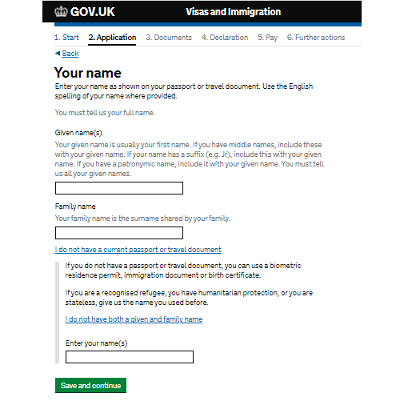
If you have been known by any other names, then you will be given an opportunity to provide these details on the next screen.
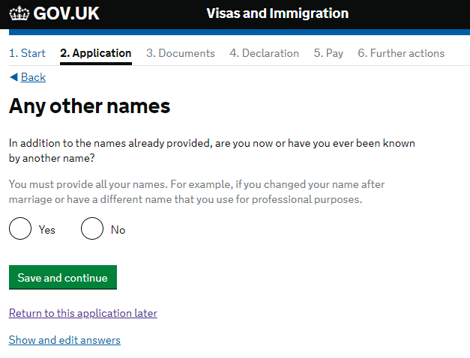
If you have been known by any other name in your life, then you must provide the details of this here. This is relevant for any given or family name that you have legally been known as in your life. You should not include any nicknames or sobriquets. You might have had a different previous name for cultural or personal reasons, or because your name changed following a marriage or adoption. If you are unsure please contact welfare@cscuk.org.uk.

Following this page you will also have to complete a few more personal details including details about your relationship status and gender.
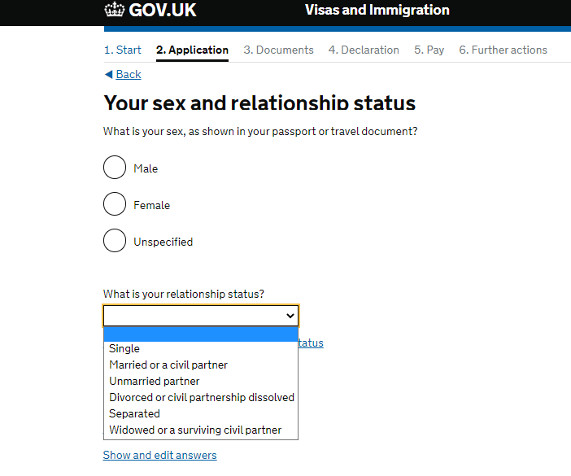
Civil partnerships are legal relationships which can be registered by two people of the same sex and gives couples legal recognition of their relationship.
The definition of an unmarried partner in the immigration rules is a person who has been living together with the applicant (you) in a relationship akin to a marriage or civil partnership for at least two years prior to the date of application.
If you select married/civil partner or unmarried partner, then you will need to provide some information about your spouse or partner.

The next screen will ask you for your address details.
You should use your permanent address for the country where you will be applying for your visa from.
If you have a different correspondence address then you will have an opportunity to provide the details of this.
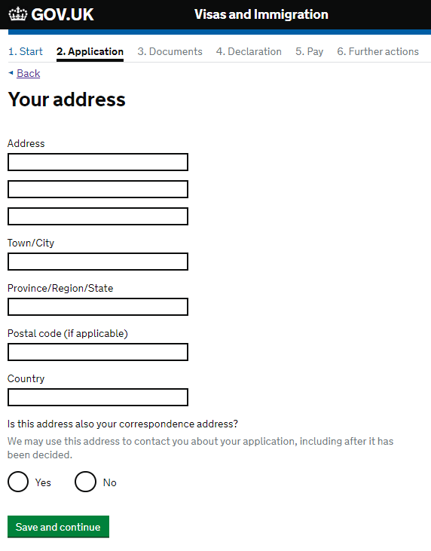
You will also need to provide some information about how long you have lived at this address and the ownership status of your home.
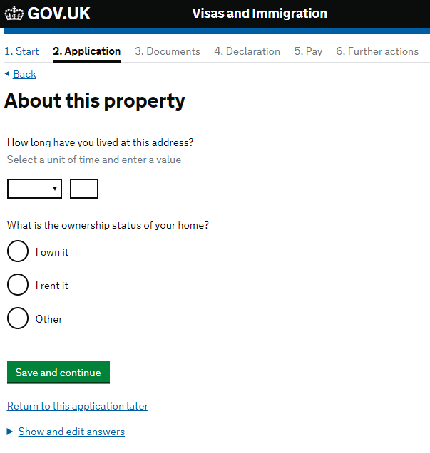
You will need to provide the details of all addresses of anywhere that you have lived in the last two years, include the dates that you lived there, so please make sure you have these details ready.

It is important that the passport details that appear on the CAS match the passport details that you submit here.
If you have received a new passport since you have provided your details to your university then you should contact your university as soon as possible as they will need to add a note to your CAS about your new passport details.
Please also send a scanned copy of your new passport to your programme officer.
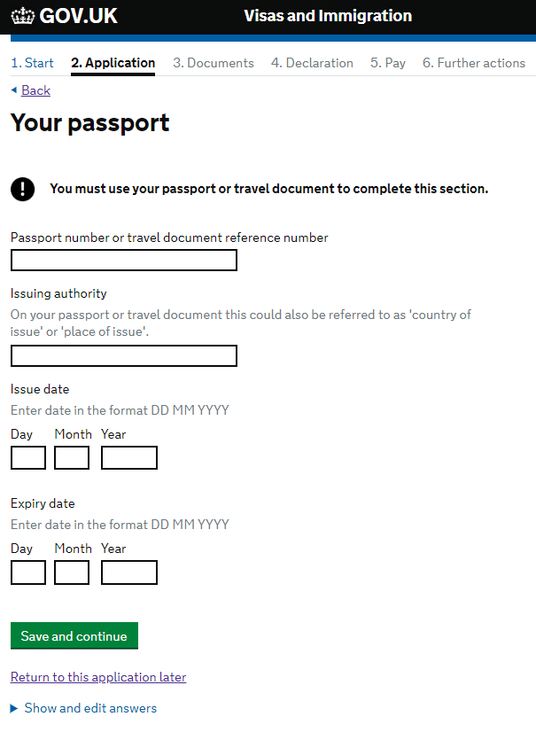
If you have a national identity card then please provide the details of this in your application.
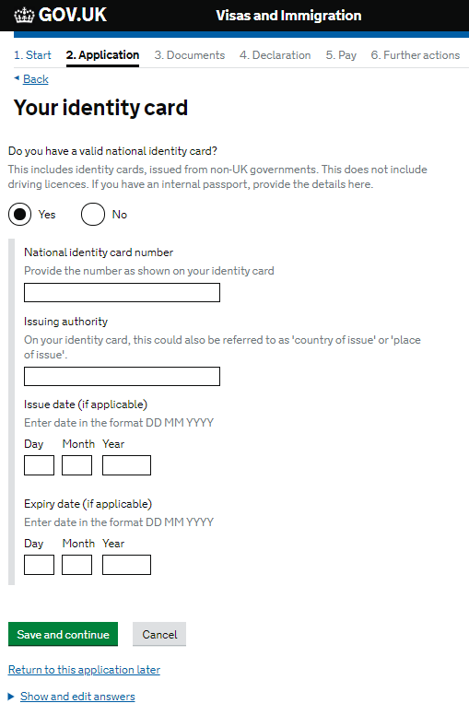
The next sections ask about your nationality.
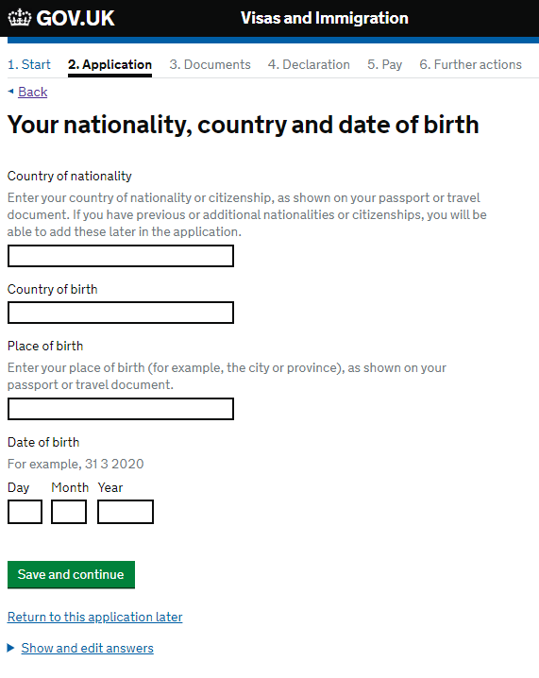
If you have other nationalities, you must provide details of this on the next pages on the application.
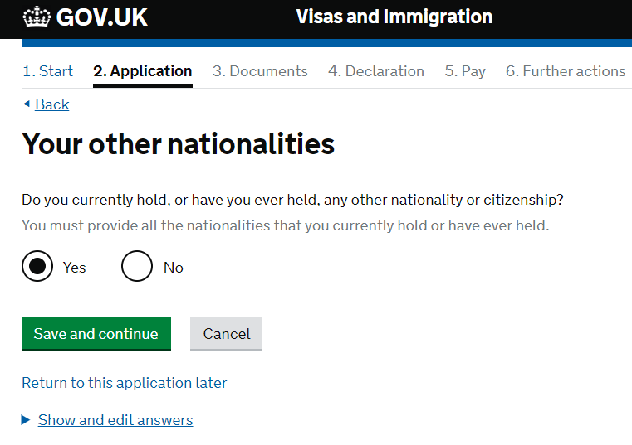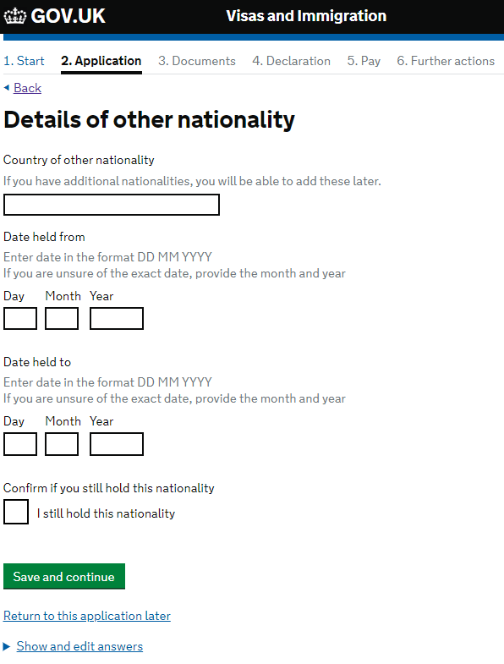
If you tick the box to show that you still hold your additional nationality, then you do not need to put a date in the ‘date held to’ boxes.
If you hold any current and valid passport for any of your additional nationalities then you will need to provide these details, like the page regarding your main passport. If you do not have access to your additional passports, then please select no to this question.
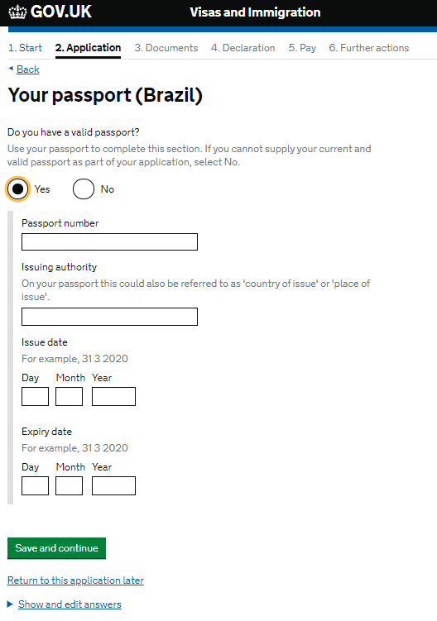
The next couple of questions asks about your English language ability.
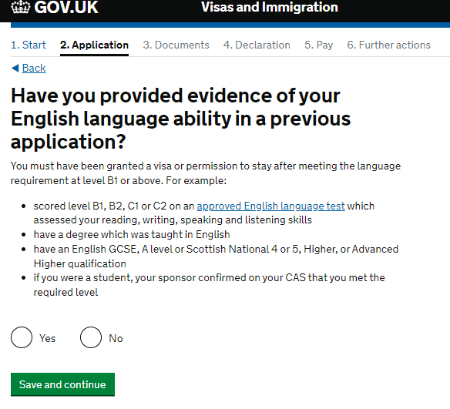
If you have had a previous UK visa and you were required to submit evidence of your English language ability as part of that visa then you can select yes to this question.
If you have not previously held a UK visa where you were required to submit evidence of your English language ability as part of your visa application, then you should select no to this question.

The next section asks you about the language you would like to be interviewed in.
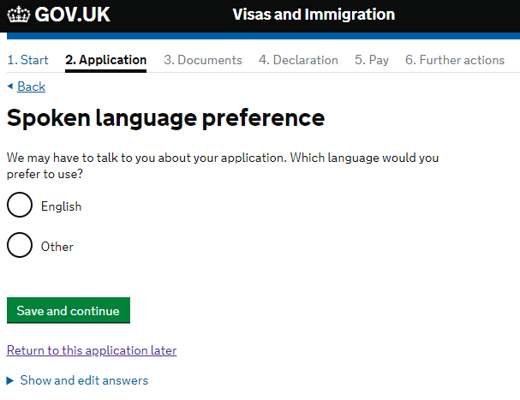
IMPORTANT: We strongly recommend that you select English as you are required to demonstrate to UKVI that you can undertake a course taught in English

If you answered no to the question regarding previous evidence of English Language ability, then you will see the following question.
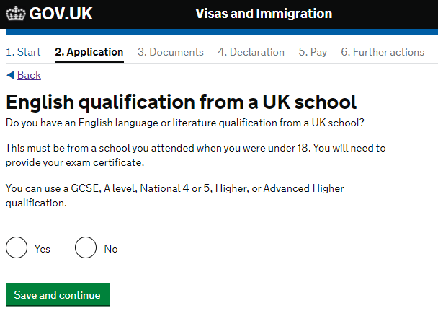

If you answered no to the question regarding English qualifications from a UK school then the following question will appear next.
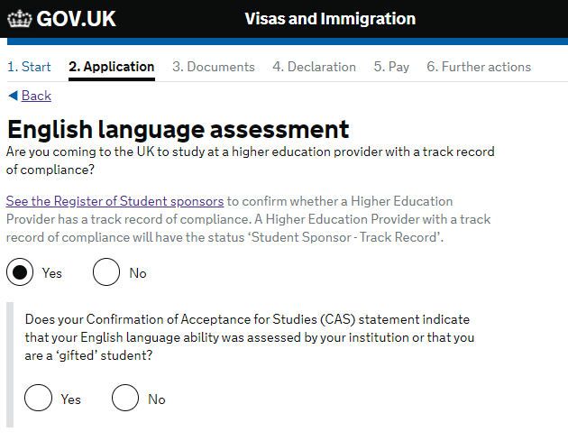
Select ‘YES’ here if your CAS indicates that your university has made its own assessment of your English language ability.
For the first question, select yes if your university or higher education provider (HEP) has a track record of compliance. For most universities, including all publicly funded universities, you can select yes to this question. This information should be on your CAS but you can also check the status column of the Register of Student Sponsors to see if they have a track record of compliance. If you are unsure please speak with an international adviser at your university.
If you select ‘yes’ to the first question you will be asked whether your institution (university) has assessed your English Language ability. This will be shown on your CAS and for the majority of scholars it will say that the HEP has made its own assessment of your English language ability. If it says something different and you are not sure what it means then please contact welfare@cscuk.org.uk.
If you’re unsure about the English language requirements please check your CAS and speak with welfare@cscuk.org.uk.
If you selected your relationship status as being married, in a civil partnership or unmarried partnership then the next screen that comes up asks you to complete the following questions about your spouse or partner.
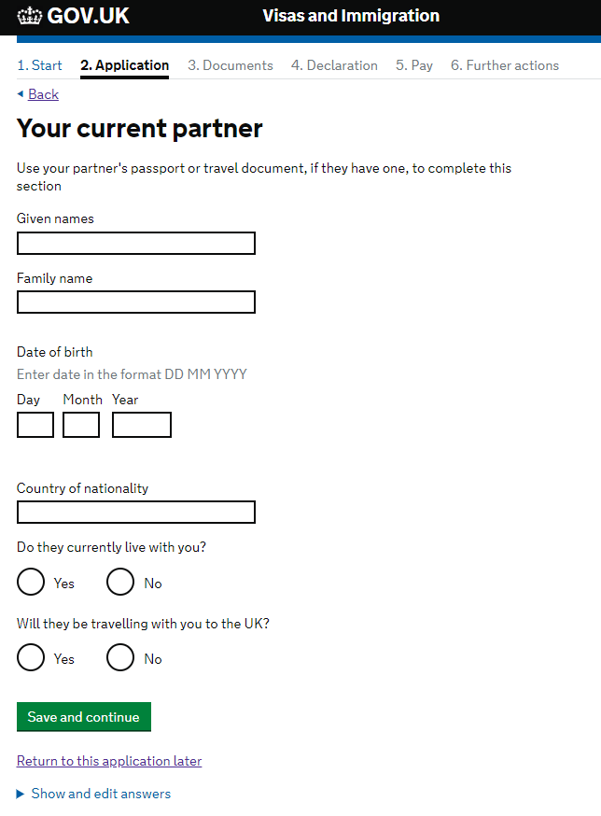
The next part of the application asks about people who are financially dependent on you.
If your dependents are travelling with you then you will need to provide their details in your visa application but a separate visa application will need to be made for each dependent travelling with you. Even if your dependants are not travelling with you to the UK you will need to provide some of their details. If they have a passport then you can use this to help you complete this part of the application form.
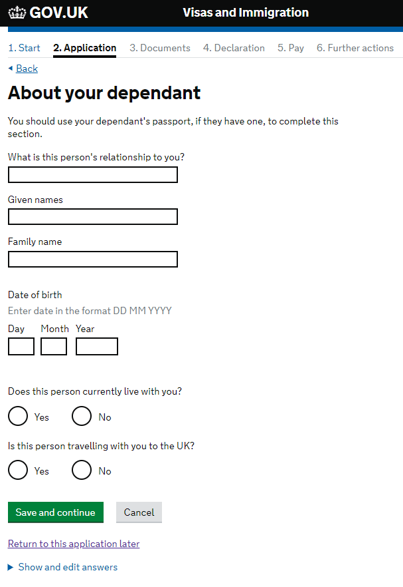
The next few questions ask you for information about your parents.
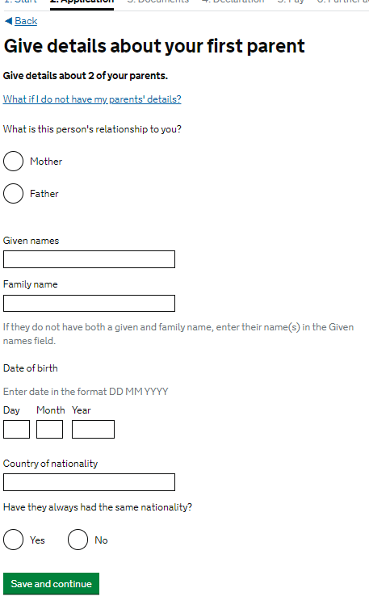
The next part of the application asks you about any family you have who live in the UK.
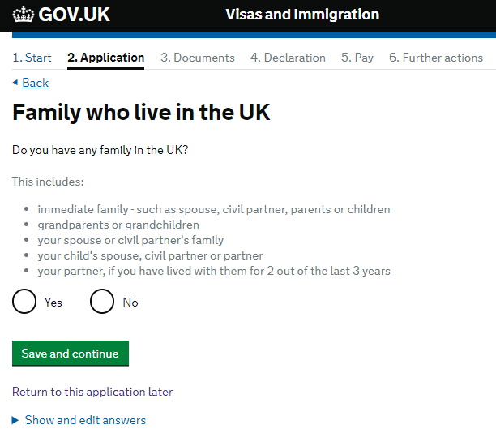
If you have any relatives living in the UK, then you will need to provide their details including information about their immigration permission in the UK. If you do not know the full details of your relative living in the UK, then it may be necessary to contact them to ask them for the required information.
As well as the family members listed on the application page, as shown above, you should also include the details of any siblings and stepsiblings, or siblings and step-siblings of your spouse or partner that are living in the UK.

On this page you should provide the details of any relatives you have in the UK.
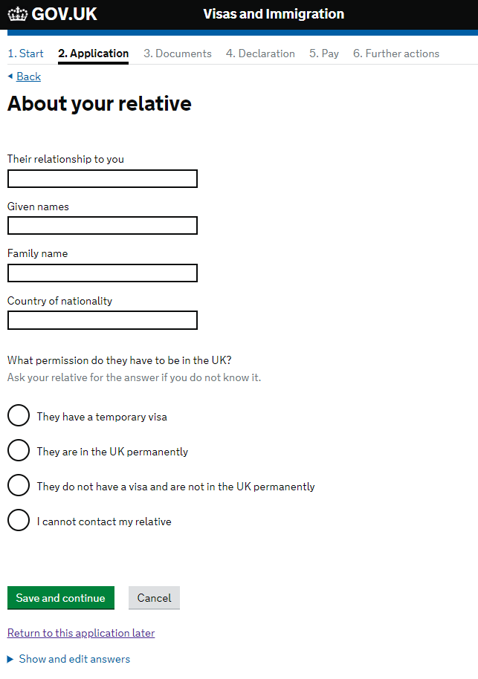

The next question asks about travelling as part of an organised group. Please select no.
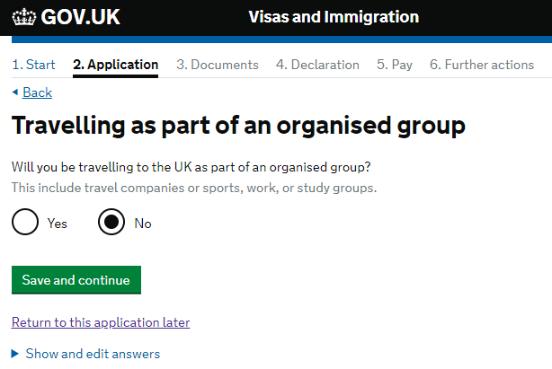
If you are planning on travelling to the UK with another person, who is not your spouse, partner or dependent then you can provide their details here.
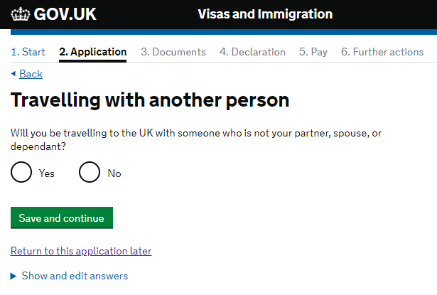
If you are staying with a family member during your stay in the UK then you will need to provide their address details and the details of when you will be arriving and when you will be leaving the address. If you are not staying with a family member then you can leave this screen without selecting any option and simply click save and continue.
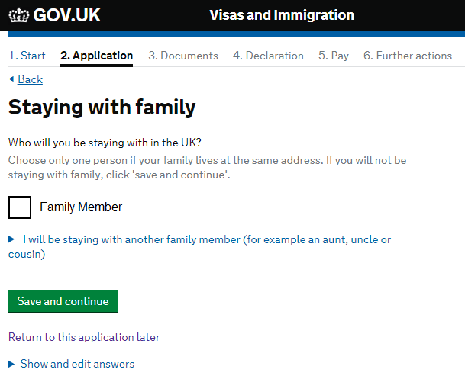

The next couple of pages ask about your accommodation plans. If you have secured your accommodation, you will be asked to provide the details. Having the postcode for your accommodation will help you complete this part of the application.
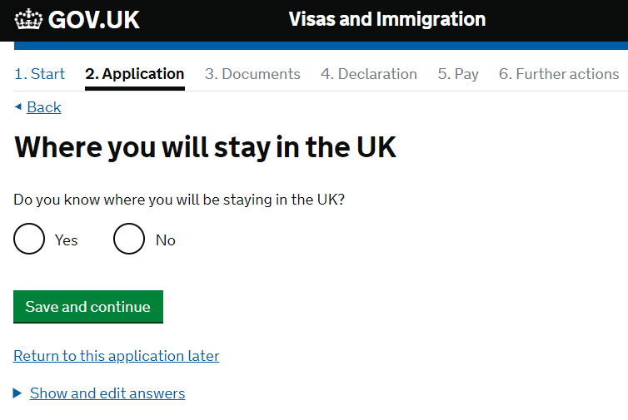
If you have not yet secured your accommodation, then you will need to provide some explanation as to how you will plan your accommodation.
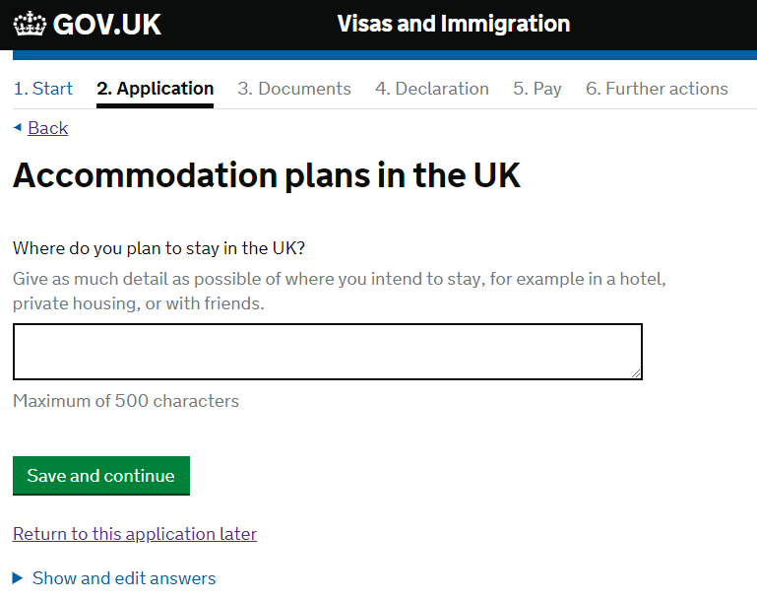
The next few pages will deal with your travel history to the UK and countries other than your home country.
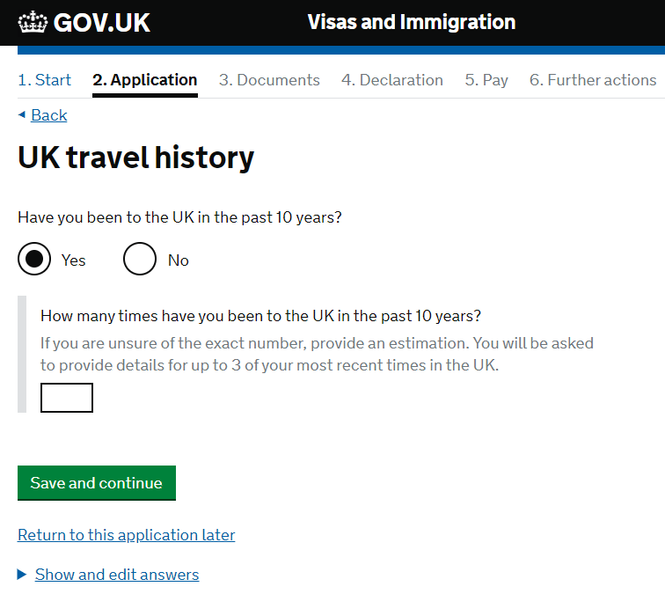
The UK is defined as England, Scotland, Wales, and Northern Ireland.

If you have travelled to the UK one or more times in the past 10 years you will need to provide details of your three most recent visits, starting with the latest.

When filling in this section, it will be useful to have your current passport and any other expired passports with you as you will need to remember the reason for your travel, the date that you visited the UK and how long you stayed for. As with all parts of the form, you need to ensure that you complete this page as accurately as possible.

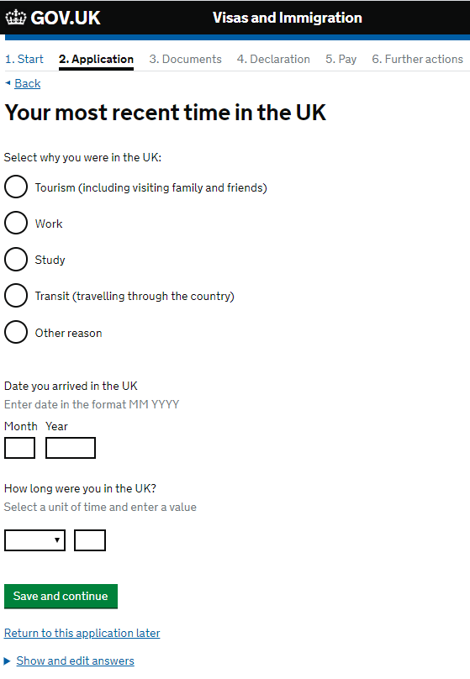

If you have travelled to the UK in the last 10 years, then the next page will ask you about any medical treatment you may have had in the UK.
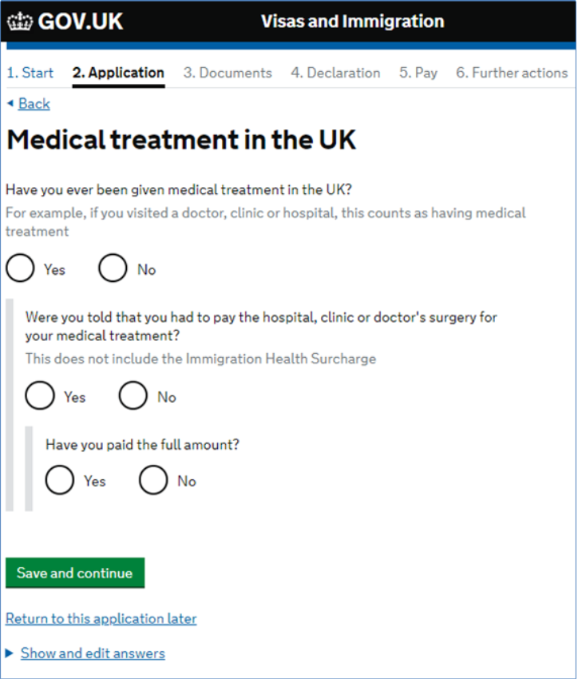
If you have previously received medical treatment from the National Health Service (NHS) in the UK and you were required to pay for it then you can explain this here. Most NHS medical treatments would not have incurred a charge if you paid the immigration health surcharge as part of your previous visa application. Treatment in an Accident and Emergency department should have been free of charge. Most other non-emergency treatment may have incurred a charge depending on the visa you had at the time of your stay in the UK.
If you have received any medical treatment, then you will be able to provide the details of this on the following page. It is important that you complete these parts of the form accurately. If you have any queries about this then please contact us on welfare@cscuk.org.uk.
If you only received medical treatment from a private provider, which you have paid for, then you will not need to answer yes to these questions. You will not need to answer yes if the only costs you had to pay were for prescription medication at a pharmacy.
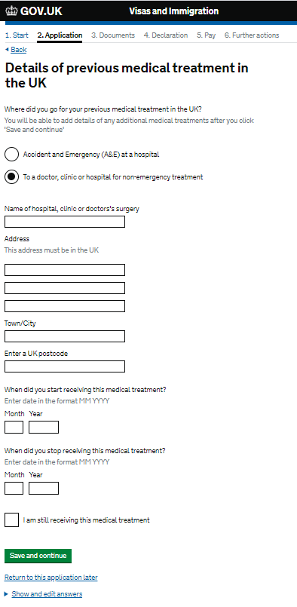
The next page will ask you about any previous applications you have made seeking permission to remain in the UK. This means applying for a new UK visa whilst you were already in the UK with a current valid visa.
If you select ‘No’ to the question ‘Have you applied for leave to remain in the UK in the past 10 years?’ then you will move to the next section of the application form.
If you select ‘Yes’ then you will need to provide the details as indicated below.
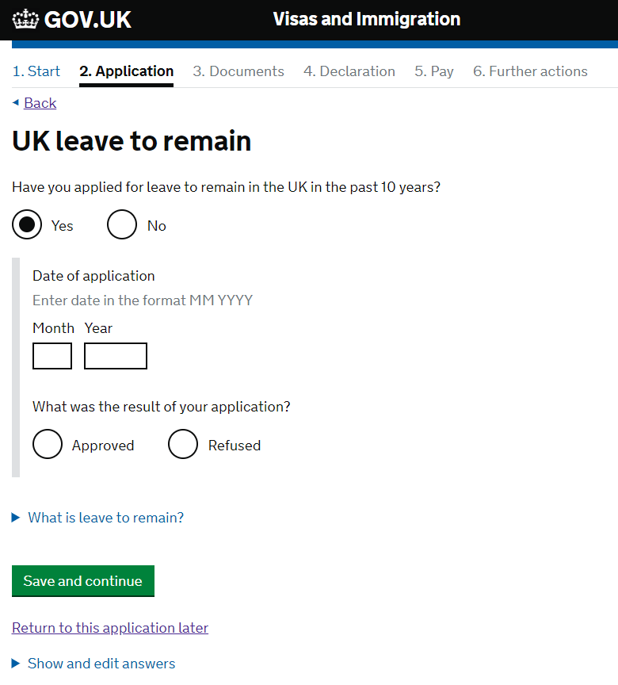
If you were refused a visa, then please contact the Welfare and Immigration Team at welfare@cscuk.org.uk.
If you have previously worked in the UK, you may have a National Insurance number. If so, you should provide details of it here. If you do not have a National Insurance number, you can answer ‘No’ here and move on to the next screen.
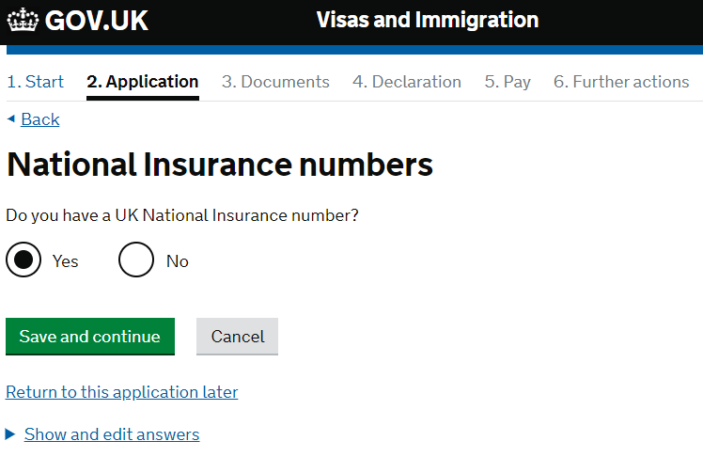
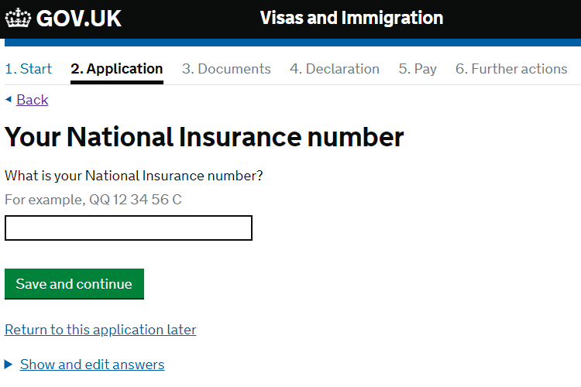

If you have a UK driving licence then you will need to provide the details of this here.
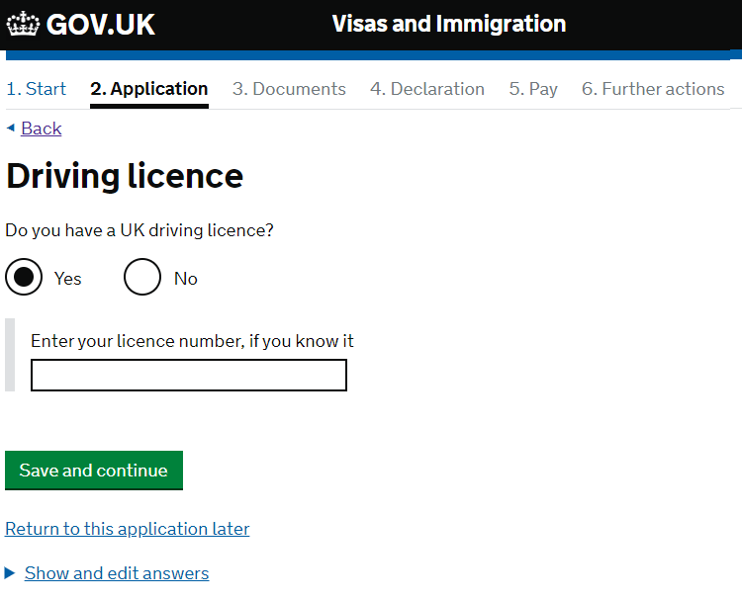

It is very unlikely that you will have received public funds whilst you were in the UK, but if you have then please provide the details in the following pages.
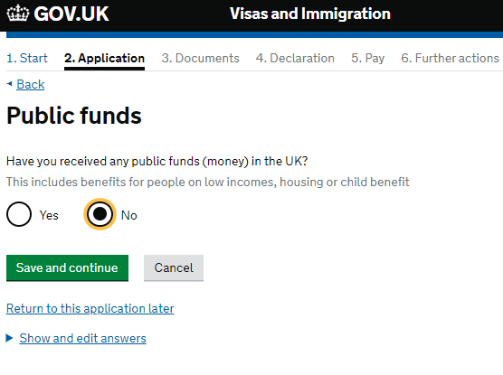

If you did receive public funds and selected yes to the question above, you will then see a page listing the different types of funds that you may have received. Please tick all that apply to you. You must tick the box to confirm that you have documents to show the public funds you have received before you can proceed, so please make sure you have those documents before you submit you visa application. You will be asked again at the end of the application to confirm that you have these documents.
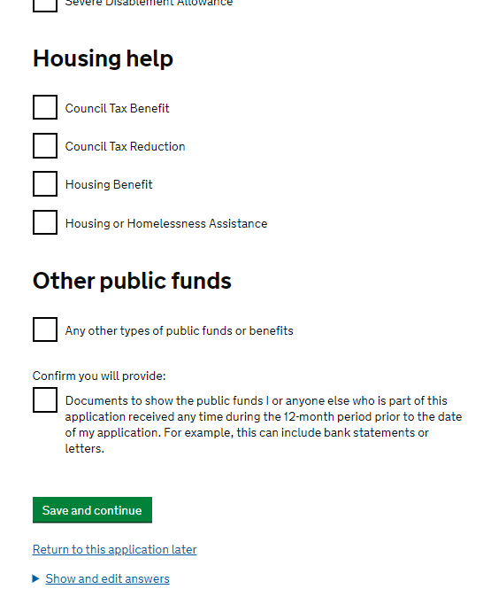

If you have travelled to Australia, Canada, New Zealand, USA, or a country in the European Economic Area (EEA) within the last 10 years you will need to provide some details regarding this in the following section. You can find a list of EEA countries here. If you have travelled to any of these countries, then the next screens will ask you to provide some details of your two most recent trips so it will be useful if you have your old and current passports to help you complete this section as accurately as possible.
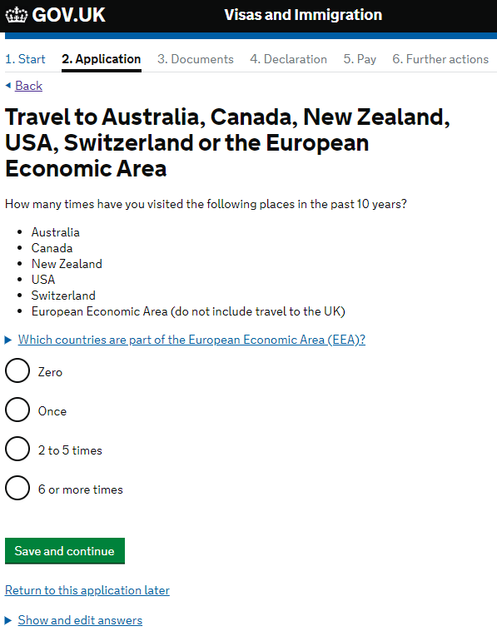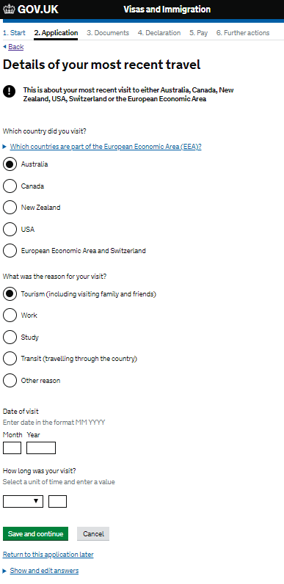

You will also need to provide any details of all other countries, not including UK, USA, Canada, Australia, New Zealand, or the EEA that you have visited within the last 10 years. You will see a similar screen to the one above to provide the necessary details.
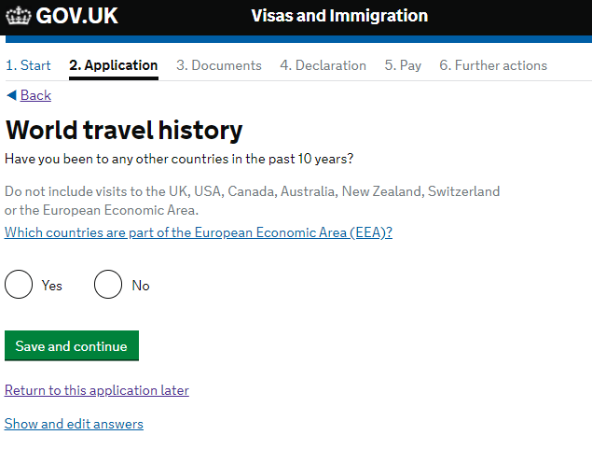

The next set of questions ask about your travel plans. The earliest date you can come to the UK is one month before the start date on your CAS. If you do not know when you intend to travel to the UK, we would advise that you select the date that is one month before your course start date on your CAS.
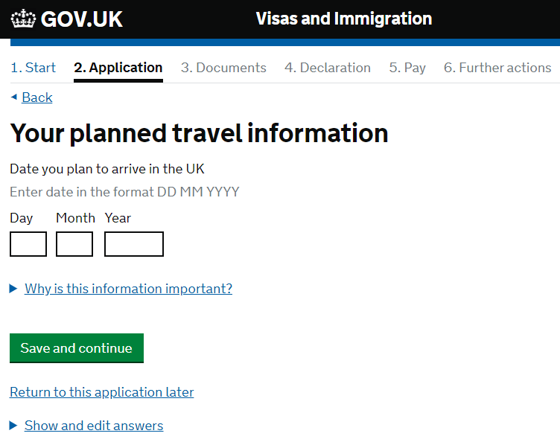

The next part of the form asks about any previous issues with immigration to the UK and other countries.
If you have ever been refused a visa, or been deported, removed, or required to leave the UK or another country or refused entry at the UK border or the border of another country then you will need to provide these details at this point.
You should select yes to this question even if visa refusals were subsequently overturned on appeal or after an administrative review.
Please contact welfare@cscuk.org.uk for further advice if you need to select ‘yes’ to any of these questions.
If you have had immigration issues on more than one occasion, then you will have the chance to answer this question several times.
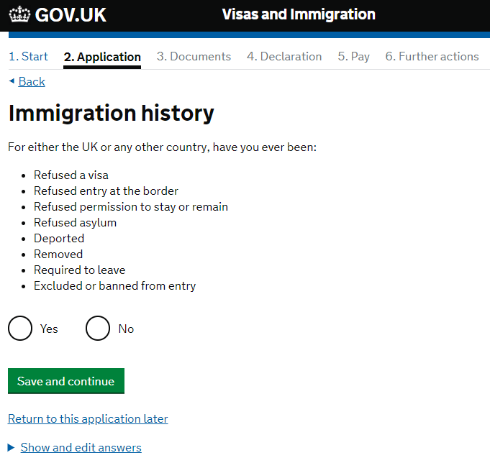
Excluded or banned from entry means that the Secretary of State has directed that your presence or entry to the UK is not conducive to the public good and any visa application will face mandatory refusal.

Refused Asylum means that you have made an application for asylum which has been refused.

Refused entry means that you were not permitted to enter the UK, for example at the airport.

Refused a visa or refused permission to stay or remain in the UK or another country means that you have made an application to enter or remain in the UK and has been refused.

Required to Leave does not mean that you left because your plans changed, but that you were served with removal papers and were required to leave.

Removed means that you were forcibly removed from the UK because of a breach of the immigration rules.

Deported means that you were subject to a deportation order in the UK.

If you have answered yes to the previous question, then you will be taken to this screen. You must answer this section accurately and honestly. If it is determined that you have withheld information or used deception during this part, or any other part of your visa application, then your visa will be refused, and you could be banned from traveling to the UK for up to 10 years.

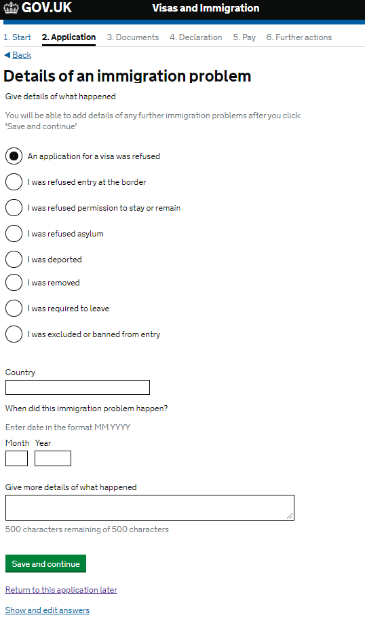
If you have ever entered the UK illegally, or remained in the UK beyond the validity of your visa or permission to stay (also known as overstaying), or breached the conditions of your leave, for example, worked without permission or received public funds when you did not have permission, or given false information when applying for a visa, leave to enter, or leave to remain, or breached UK immigration law in any other way, then you should declare this on your application form.
If you do not answer this question accurately or withhold information then it could be determined that you are using deception in your visa application, and your visa will be refused, and you could be banned from traveling to the UK for up to 10 years.
Please contact welfare@cscuk.org.uk for further advice if you need to select ‘Yes’ to any of these questions.
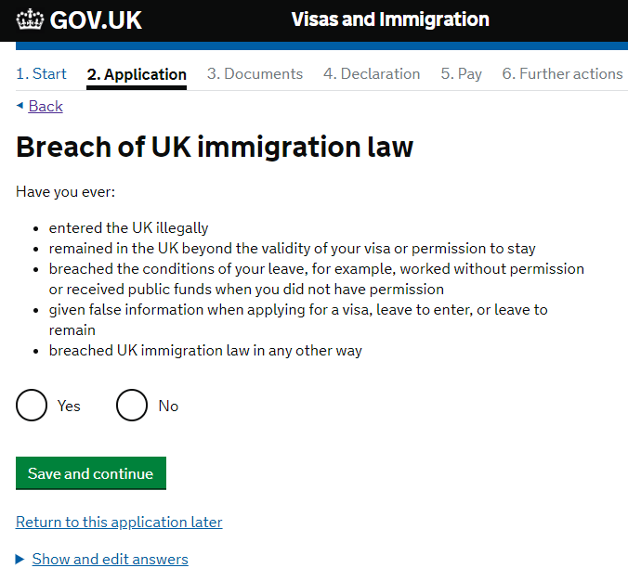

If you answered yes to the previous question, then you will need to provide some more information about your breach of the UK immigration law.
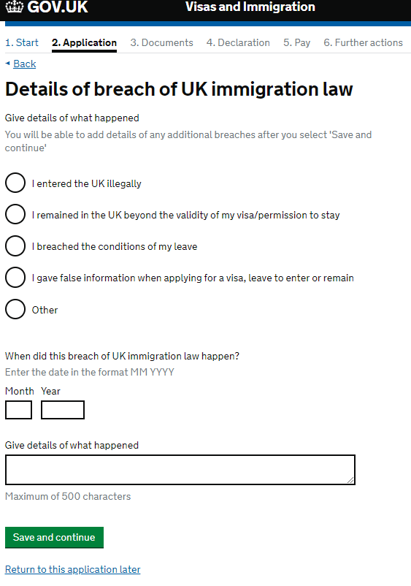
The next page will ask you about any criminal convictions or penalties you may have had whilst in the UK or other countries.
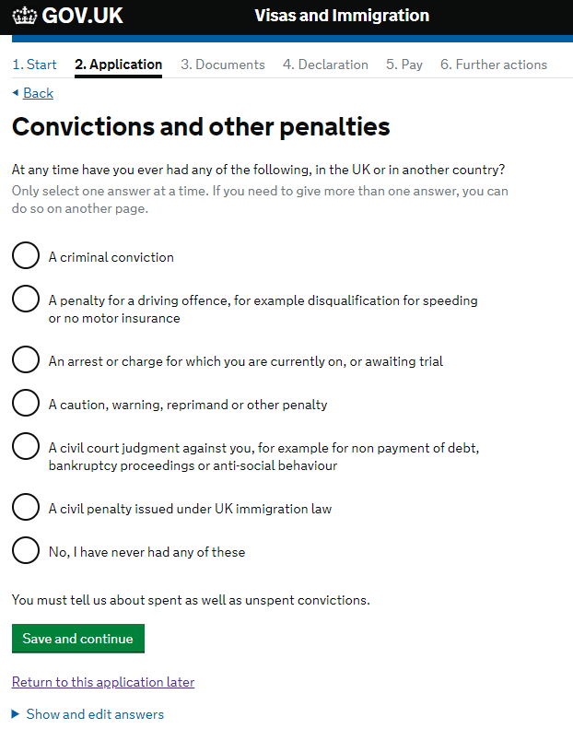
If you have received any convictions or penalties in the UK or any other country, then you will need to provide the details here. Unless you select ‘No, I have never had any of these’ you will be requested to submit further information on the next screen.
There is more information about criminal convictions on the Student visa requirements part of the UKCISA website.
If you have any concerns or questions about this then please contact us at welfare@cscuk.org.uk.
If you have had any convictions or other penalties, then you will next see a screen like the one below. Please make sure you provide full and accurate information. If you have had more than one conviction or penalty, then you will have the opportunity to answer this question more than once.
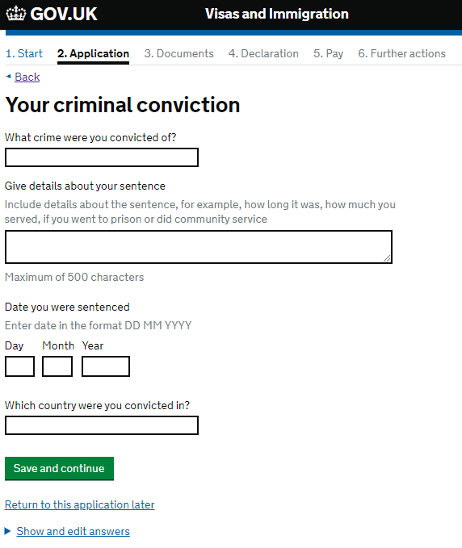
The next few screens will look similar to the one below and ask if you have ever been involved with or suspected of involvement with war crimes, terrorist activities, terrorist or extremist organisations, or whether you have expressed any views that glorify or justify terrorism, or if you have undertaken any other activity that may be dangerous to the interests or security of the UK and its allies, or that may indicate that you are not a person of good character. If you answer yes to any of the questions on these pages you will be provided with an opportunity to give more information.
Please read the information and the guidance carefully and please contact welfare@cscuk.org.uk if you have any questions or concerns.
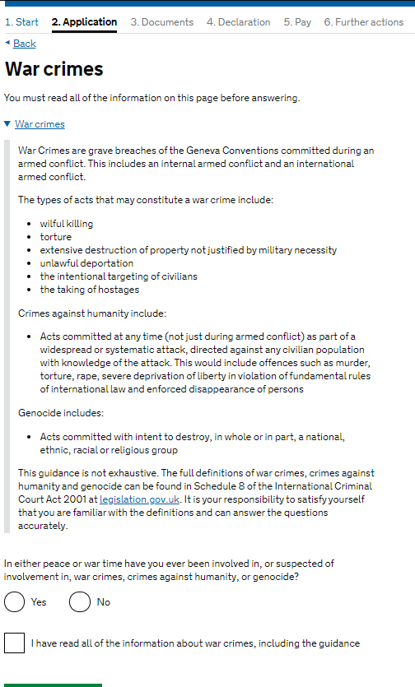
If you have been employed in any of the occupations or industries listed below then please provide the required details.
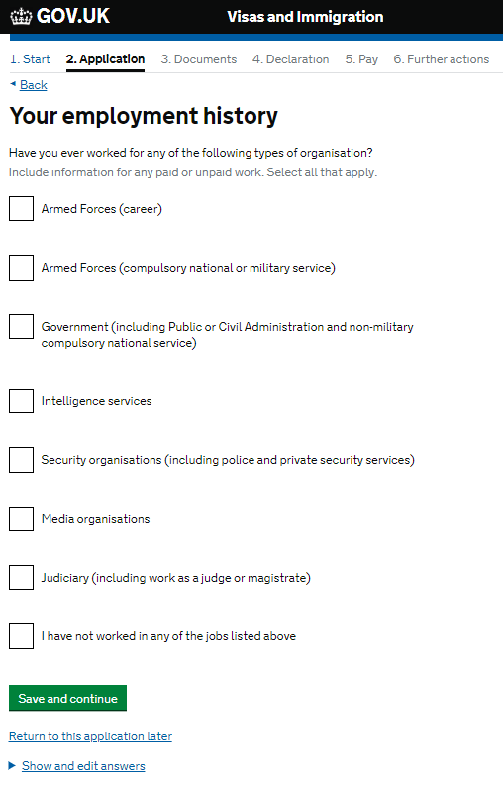
The next part of the application will ask you about your chosen university and course.
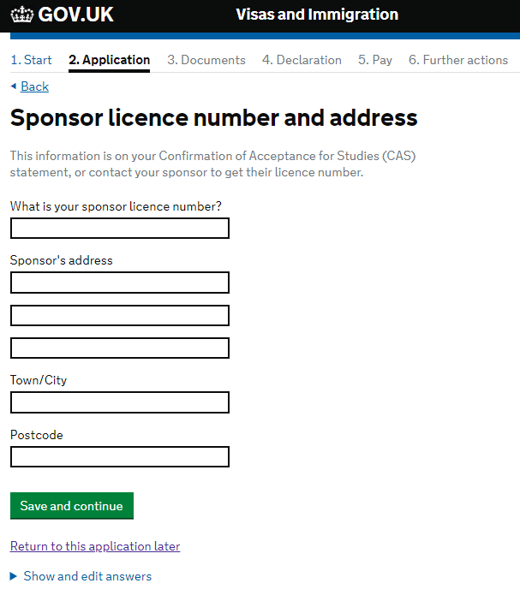
You will need to refer to your CAS to complete the details required on this page. Your CAS should have the details of your university’s Student sponsor licence number. The sponsor’s address is the address of the university where you will be studying in the UK as listed on the CAS.

The next screen asks about the type of institution that you will be studying at.
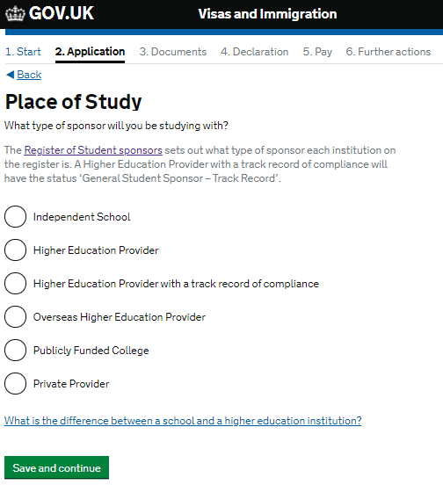
Most Universities where your award is tenable are Higher Education Provider with a track record of compliance. Please check your CAS or university offer letter for this information if you are not sure.

It may be that your choice of university has different sites and campuses. If you will be based at a different site to the main address of your university, you should enter the address of the department where you will be studying in your university in the section on the form where it asks for the address of the main site of study.
If you are not sure what department your course is being taught in, then please refer to your university’s offer of study letter.
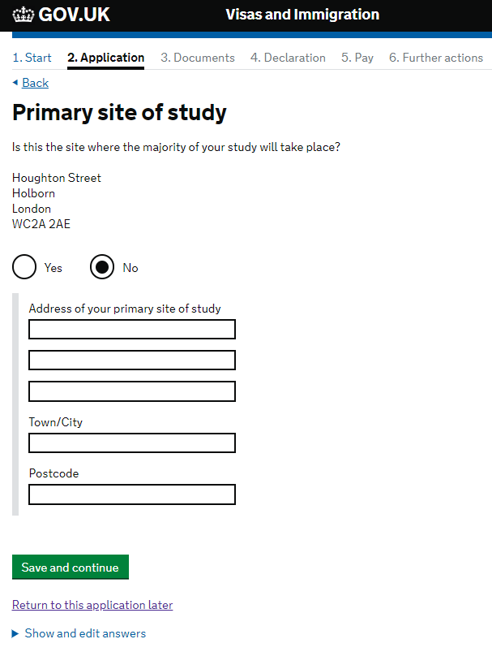
The address of your university should appear here.
The next page asks about UCAS details.
UCAS is the Universities and Colleges Admissions Service which mainly operates the application process for undergraduate degrees.
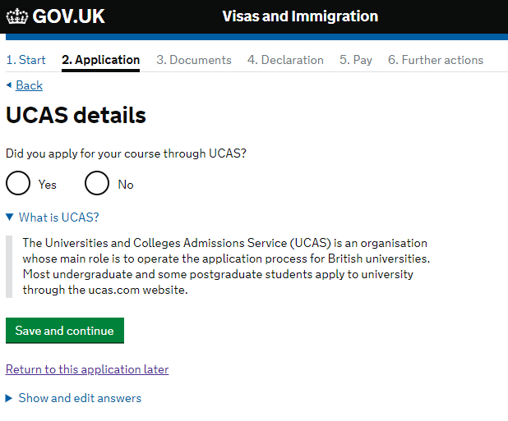
If you have applied for your programme directly to the university or via a different agent, please select ‘No’ for this question.

The next part of the application is about Academic Technology Approval Scheme (ATAS).
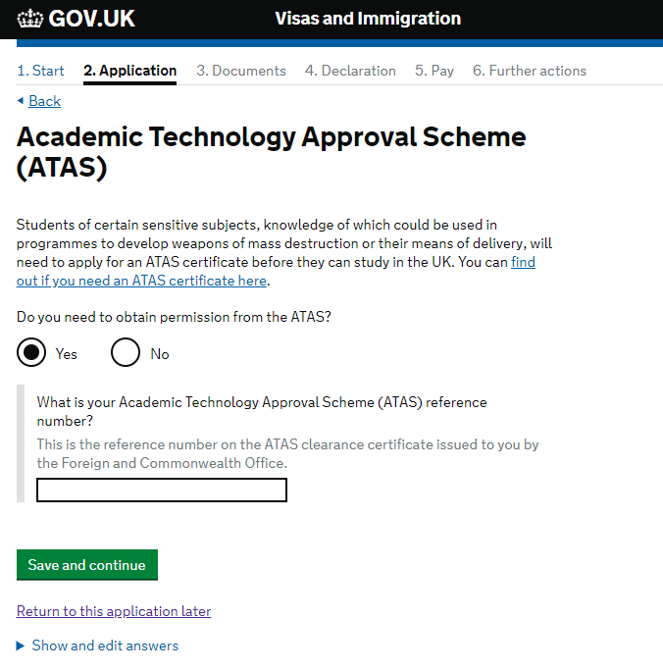
Some programmes of study require its students to secure an ATAS certificate before they can enroll on the course. If this is the case with your programme, then you will also need the ATAS certificate to secure your visa.
You should refer to your university offer letter and CAS to find out if you need an ATAS certificate or not. If you are in doubt then you should ask the course convener, programme administrator, or another relevant member of university staff.
ATAS certificates generally take 20 working days to produce but can take longer during the busy summer period, so you should apply for them as soon as you can. Once you have the ATAS certificate you can complete this part of the application form by providing the ATAS reference number. The CSC cannot intervene with the Foreign, Commonwealth and Development Office to speed up the process of obtaining an ATAS certificate.

As a CSC scholar you will be in receipt of a fully funded scholarship award. You should select ‘yes’ to the question ‘Will you be receiving money from an official financial sponsor for your continuing studies?’ and then select the option which shows that you will prove this with a ‘letter of official financial sponsorship’ so please choose this option. This is what we refer to as your Confirmation of Award Letter (COA).
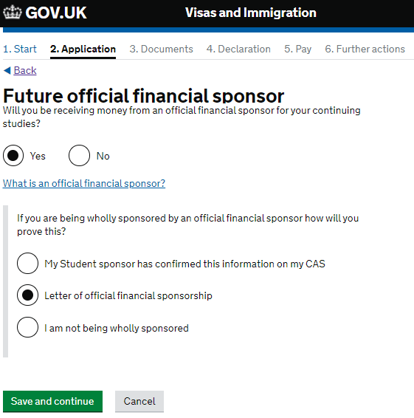

The next part of the application asks about your course details, and you will need your CAS to answer these questions.
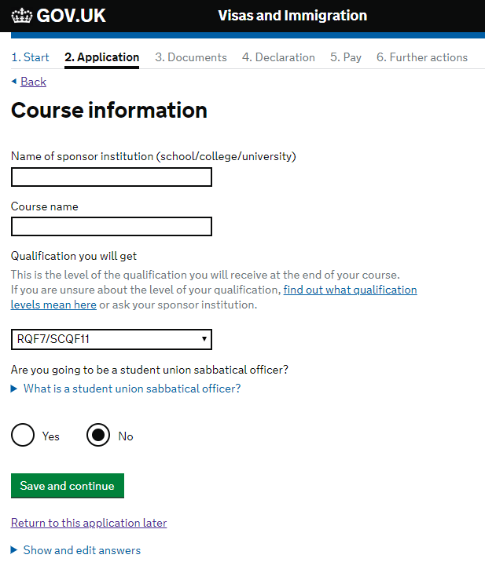
Enter your course information as it is shown on your CAS. Your qualification should be stated on your CAS and should be either RQF Level 7 or SCQF Level 11 for a masters level course or RQF Level 8 or SCQF Level 12 for a PhD or doctorate level course. Please note that some CAS still use an old framework notation, in which case NQF Level 7 is the same as RQF Level 7 and NQF Level 8 is the same as RQF Level 8.
Please select ‘no’ for the question are you going to be a student union sabbatical officer.

The next page will ask you about your course start and end dates. Please refer to your CAS to find the official course start date used by your university for your chosen course.
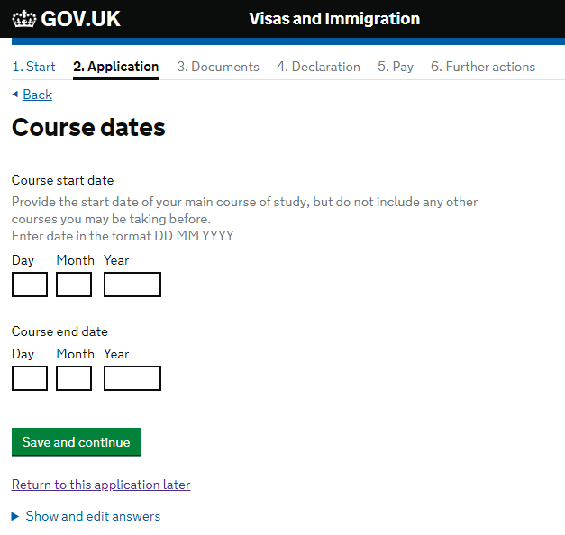

The next section asks about accommodation payments.
This page regarding accommodation only applies to you if you are staying in university owned or managed accommodation. If you have not made any accommodation payments, then select no and move on to the next section. If you have made some accommodation payments, then please provide the details.
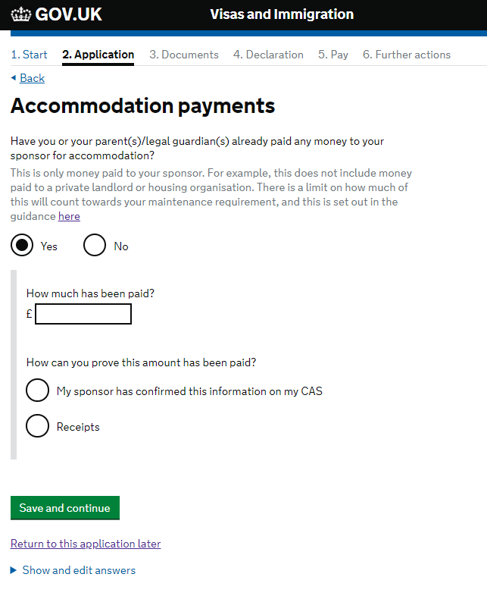
The amount that you fill in here should match what is on your CAS or receipts.
Only answer yes here if you are staying in university managed accommodation and you have made a payment towards your accommodation.
If you are using receipts to prove that payment has been made, then you will need to submit these with the rest of your documents at your visa appointment.
This next part of the form asks about your course fees.
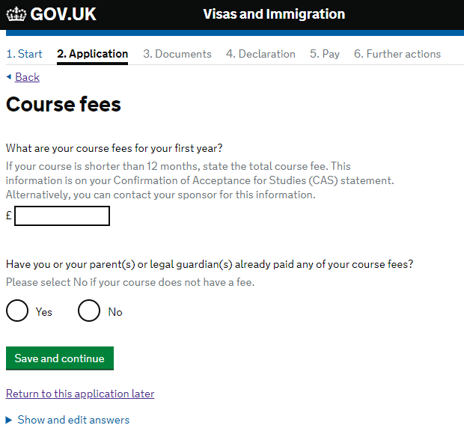
The first question here asks about fees. Please enter the ‘total academic fee’ for the first year of your course in this box, not just the percentage that the CSC is paying or your university is paying. You should have this information on your CAS and Confirmation of Award.
For the question ‘Have you or your parent(s) or legal guardian(s) already paid any of your course fees?’ you should check your CAS. Some universities will class your fees as already being paid because of your scholarship. Others will not, so check your CAS. If you select yes to this question the following question appears. Please refer to your CAS and fill in the box with the figure that has been confirmed as having been paid.
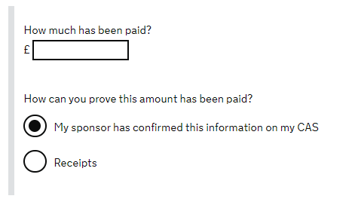
As you are a fully funded scholar your COA proves that you meet all the financial requirements of your visa. In this case, please select ‘No’ to the question about whether you will be in receipt of a student loan.
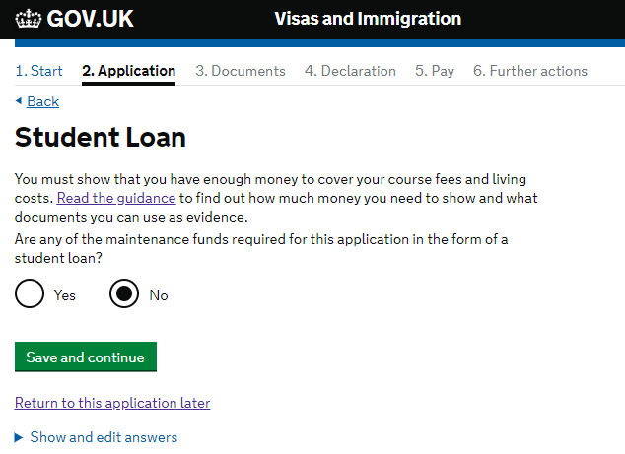

This part of the application is asking about funds for your course fees and living costs. Because your funds are being provided by your CSC scholarship you do not need to hold any additional funds in a bank account so you can answer no to both questions on this page.
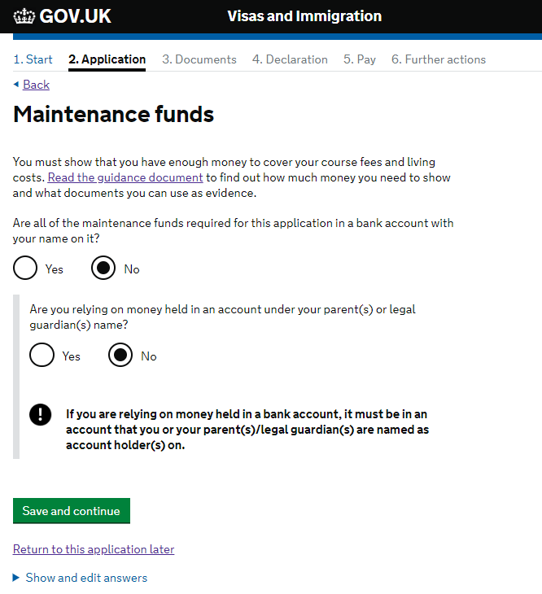

If you have answered any questions during your online application which you feel requires further information or explanation, then please use this box to provide any extra detail.
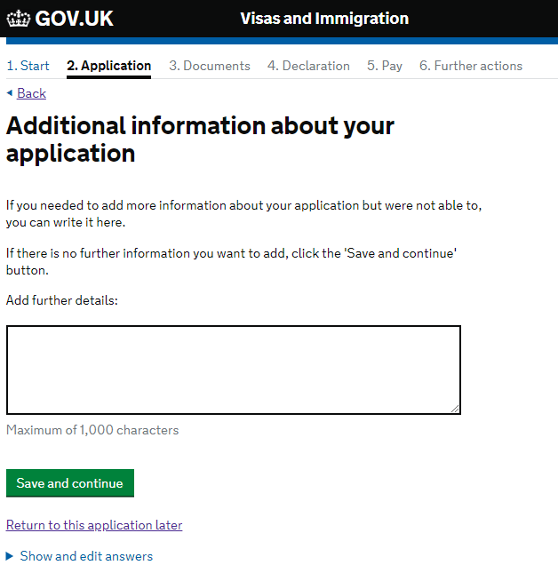
Click here to review and edit any of the answers that you have provided for each question.
You may wish to write ‘As a recipient of a CSC scholarship, all course fees and living costs are paid by the Foreign, Commonwealth and Development Office as per the Confirmation of Award letter which includes a partnership contribution from [insert university]’ to make it clear that you are a CSC scholar.
Once you have completed this question you will be given a chance to review all the answers you have provided for each question before moving on to the next part of the application. Please take the time to check that you have answered each question as accurately as possible.
The next section of the application summarizes the documents that you will need to provide as part of your application.
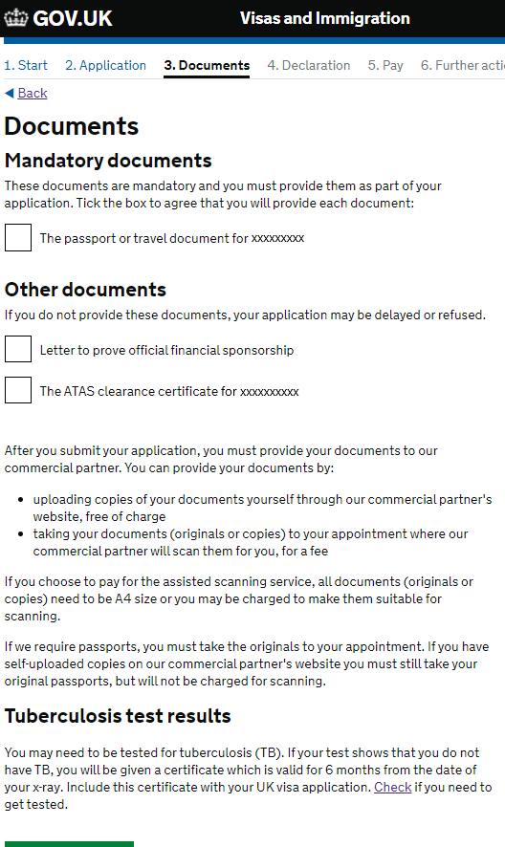
Depending on your residential history of the last 6 months you may need to submit a TB certificate. You can read more about on the gov.uk website.
Please note that whilst copies of most documents is permissible, any passports that are required must be original documents.
This is the COA that the CSC will provide to you once your scholarship is confirmed. Please make sure you remove the password protection before you upload it later in the process
Depending on some of the answers you have provided in the application form, you will see a list of other documents you should provide, such as an ATAS certificate in this example.
When you have complete the application you can click on your name in the top right hand corner to download a copy of your application form. We would advise that you do this and keep a copy of the application form in a safe place.
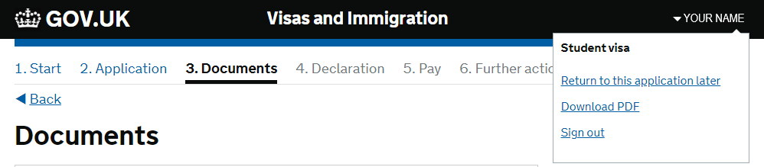
Once you have completed the details about your documents you should read the information about your visa which you will need to accept if you wish to proceed.
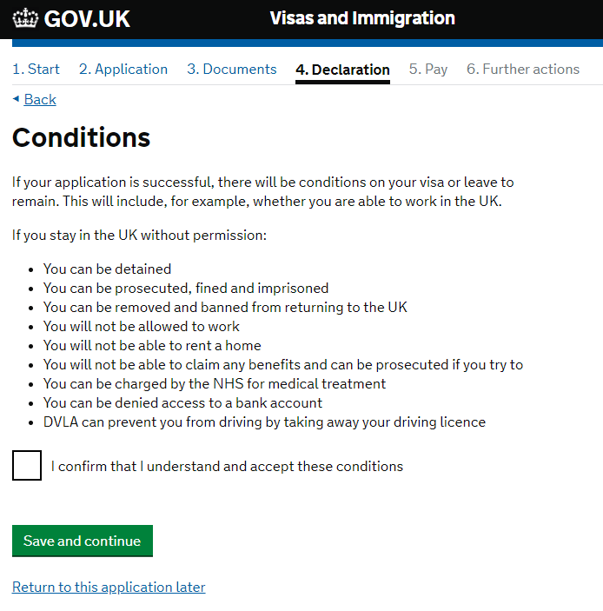
One of the final parts of the application is the declaration.
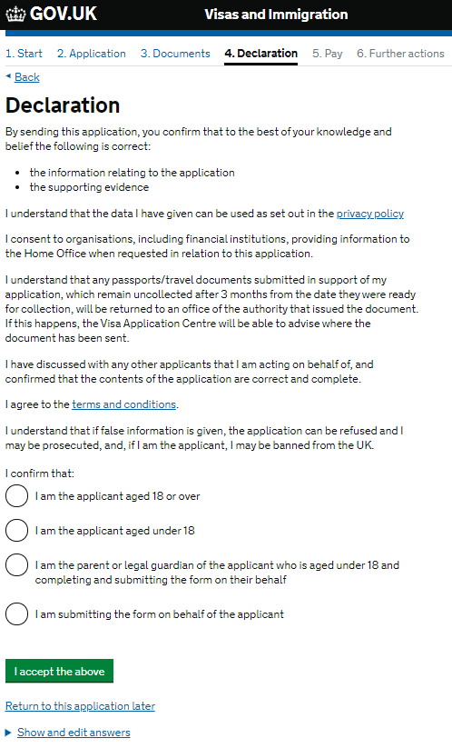

Once you have completed the application and confirmed that you have all the required documents, you will need to complete this declaration that confirms that, to the best of your knowledge, you have provided correct information. It also confirms that you accept the privacy policy and accept the terms and conditions of the application.
Once you have accepted the declaration, the next screen will be about the Immigration Health Surcharge (IHS).
As a Commonwealth scholar you won’t need to pay for the IHS but you still need to provide your details on the IHS website. This will ensure that you are given an IHS number, which you will need in order to access the National Health Service once you are in the UK. Please ensure that you have selected ‘yes’ to the question ‘Do you have a Marshall, Chevening or Commonwealth Scholarship’ as shown on page 10 of this guide.
You should only continue once you are happy with all the answers you have provided in the previous part of your application form, as once you have proceeded to the IHS website you will not be able to amend any other part of your application.
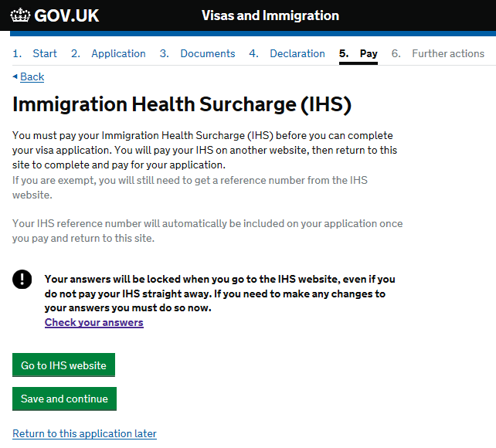
Please note that it is not possible to amend your answers once you have continued onto the IHS website so please make sure that you have double checked that the information you have provided is correct.

You will be redirected to the IHS website and you will see the following screen. This provides some information about how the IHS is calculated. As a Commonwealth scholar you will be exempt from paying the IHS. There is more information about this on the Government website. Please note that the IHS calculator on the Government website is broken and may show that your dependants would not be required to pay the IHS when in fact they will need to pay based on the calculation shown below.
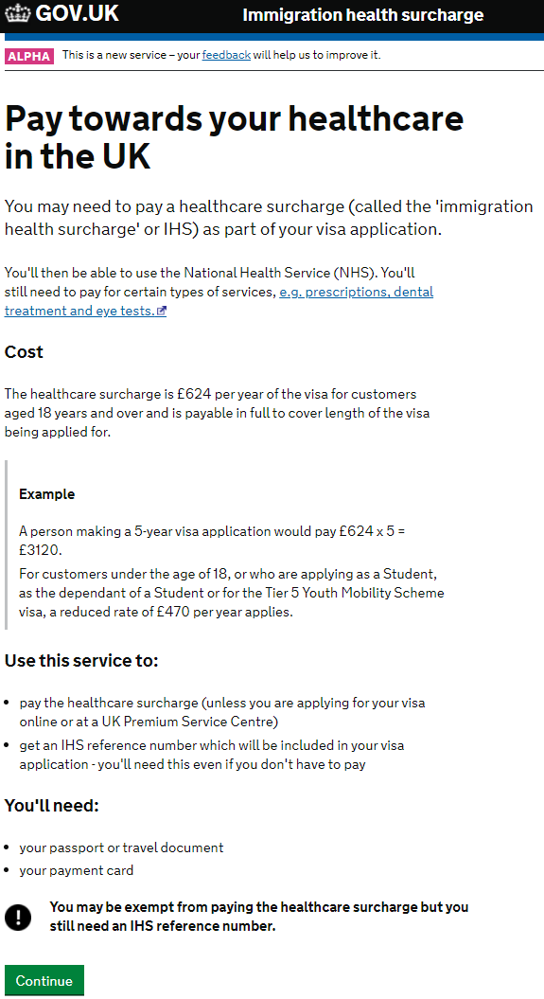

When you click continue you may need to provide some details again but most will be automatically completed based on your main application so please check to make sure that these are correct.
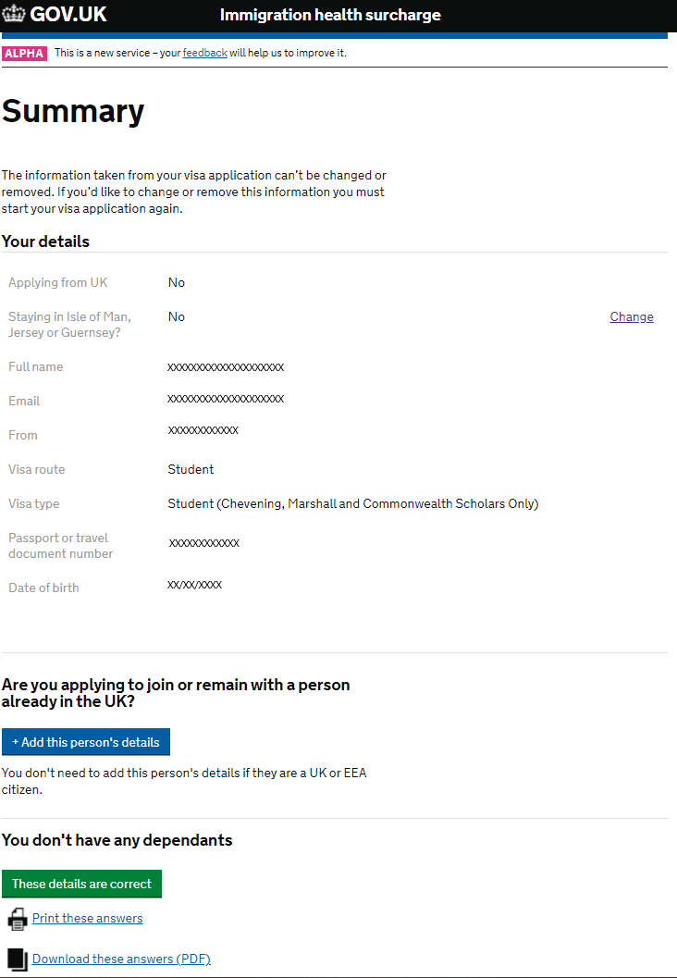
Once you are happy with the details above you will be taken to the payment summary screen. This should show a balance of zero in your local currency.
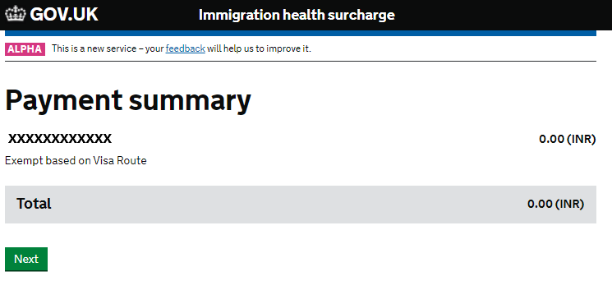
You should then go to a screen which shows your IHS number and you should also receive an e-mail confirmation with these details within a few minutes. You can now return to your visa application.
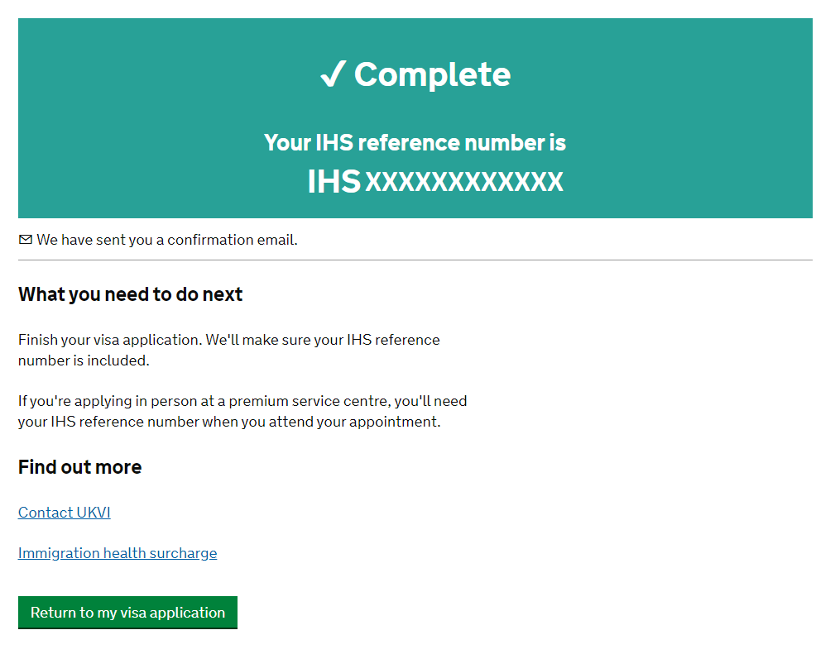
The next few pages will take you through the payment pages of the application. Again, as a Commonwealth Scholar you should not need to pay for your application.
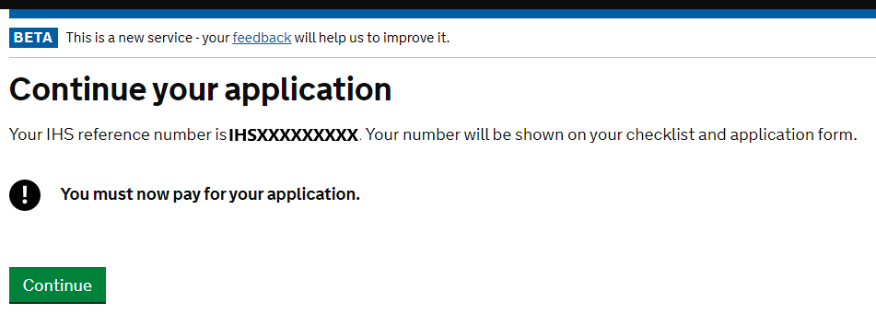
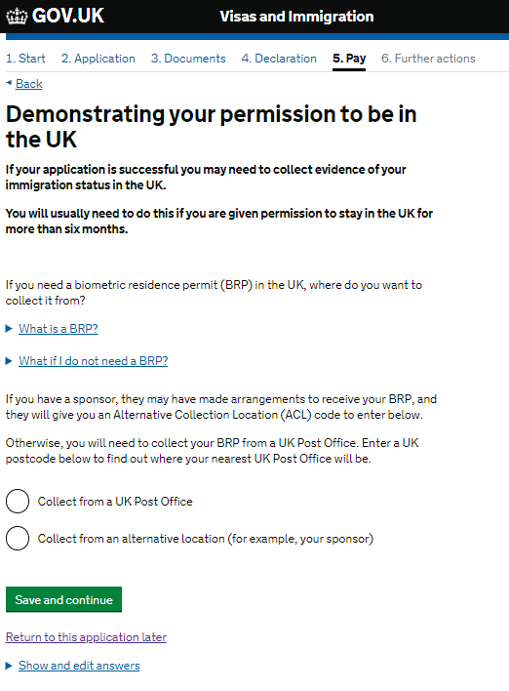
You will first need to select where you will collect your BRP once you are in the UK. You will have the option of collecting your BRP from an assigned Post Office by using a specific postcode. If you chose this option, it is best to choose a Post Office near your accommodation or university, so you should use that postcode to find the nearest Post Office to you.
Please check with your university to see if they have and Alternative Collection Location code. Some institutions have arrangements in place to distribute your BRP and you will need this information for this part of the application.
Once you click confirm you will receive a message asking you to confirm that the location is suitable. We advise you to check the location of the Post Office or Alternative Collection Location on a map before you do this.

Once you have passed this page you will come to a screen confirming that no payment is required. The website here says that most people get a decision on their visa within 15 working days. This will be 15 working days from the date that you attend your visa appointment. However, you may experience delays in receiving your visa if you are applying in August and September.
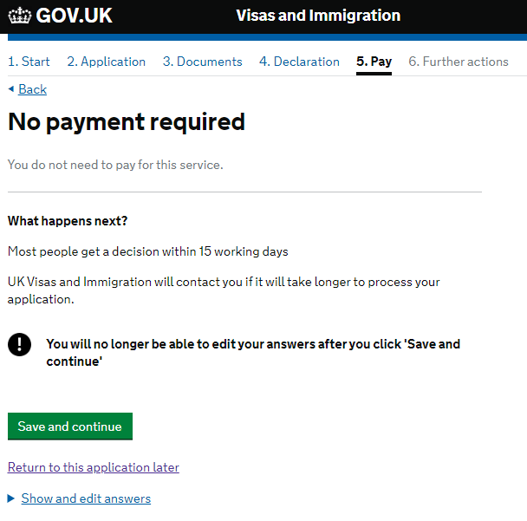

You have now submitted your visa application and you should see the screen below. You will also receive e-mail confirmation within a few minutes of coming to this screen.
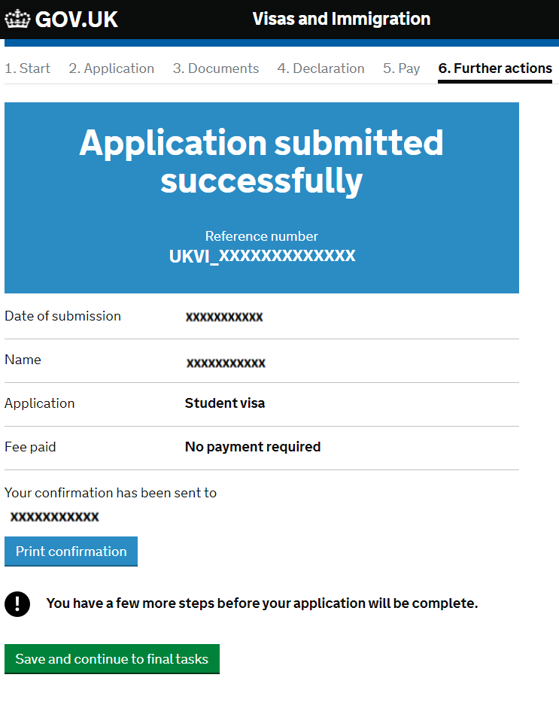

There are further actions that you will need to take to complete your application. The most significant of these is booking your visa application centre (VAC) appointment and uploading your documents.
DOWNLOAD CHECKLIST: You will need to download and print this document and take it to your visa appointment. It contains a list of documents that you will need to submit with your application.
Important: Even if your checklist does not require you to upload or provide a copy of your Confirmation of Award, we would advise that you provide this anyway as proof that you are a recipient of a CSC scholarship.
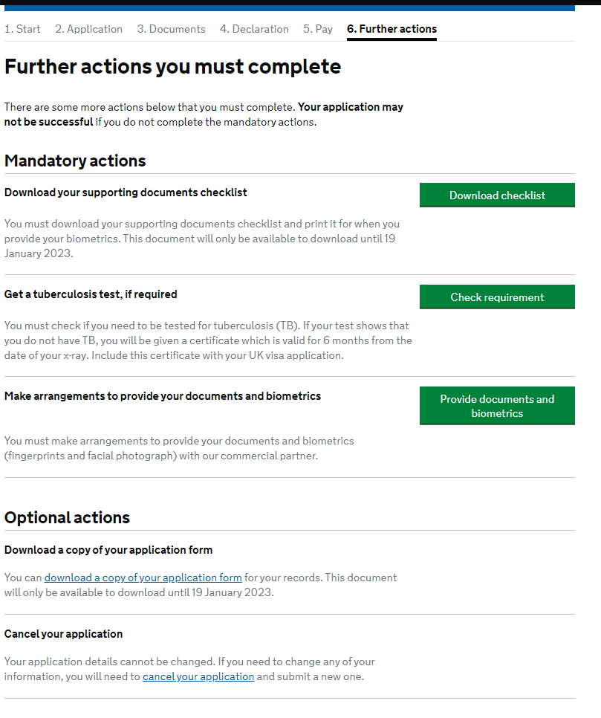
CHECK TB TEST REQUIREMENTS: This will take you to the Government website with some information about whether you need to submit a TB test Certificate. If you are unsure if this applies to you, please contact welfare@cscuk.org.uk
BOOK YOUR BIOMETRIC APPOINTMENT: Click here to book your VAC appointment to submit your biometrics. This will also take you to the pages where you can upload your documents. More information about this follows below in this guide.
OPTIONAL ACTIONS: It might be a good idea to download a copy of your application form for your own records.
If you have made an error on your application, then please contact welfare@cscuk.org.uk before you cancel your application.

This is an excerpt from the supporting documents checklist. Please note that the letter to prove official financial sponsorship is you Confirmation of Award (COA). Even if you are not asked to provide this document we would recommend that you still upload it later in the process.
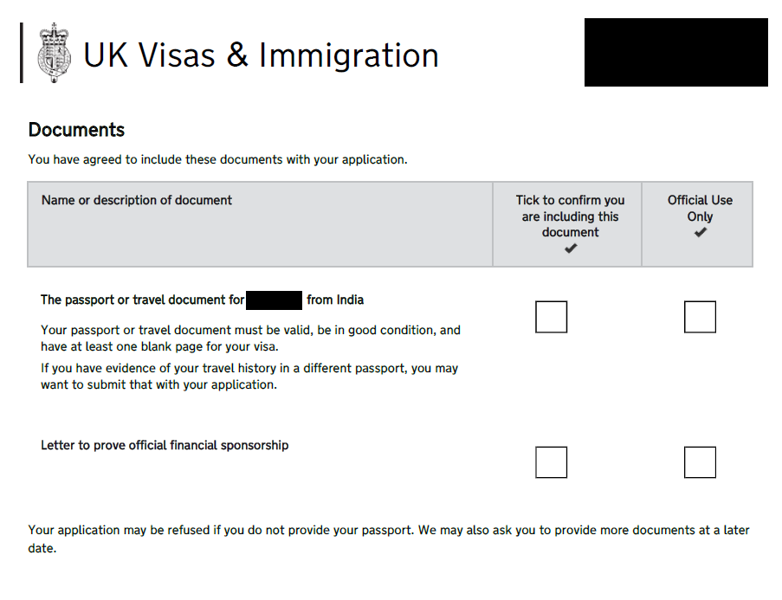
This is your Confirmation of Award (COA)

When you click on the green button to provide documents and biometrics you will be redirected to one of the UKVI’s two commercial partners, VFS or TLS Connect. This is where you will book an appointment to submit your biometric data and documents. Most fields will automatically populate with information included in your visa application form, but if they do not, please ensure that you fill in the necessary fields correctly.
The following screens show the process of booking your appointment if VFS provides the Visa Application Centre services in your country. Scroll further down for guidance if TLS Connect is providing the Visa Application Centre services in your country.
First you may need to register an account with VFS Global. Please provide your personal details and keep them safe so that you can use them to log-back in later if you need to.
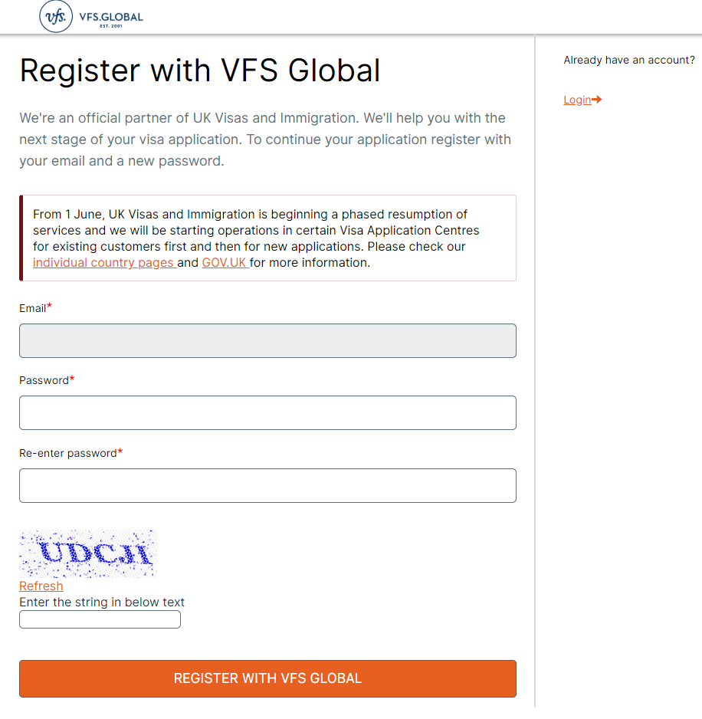
You will first need to select the location where you will need to attend the visa appointment. This should be determined by the country that you chose at the beginning of the application process, though some larger countries will give you the option of attending an appointment in different cities.
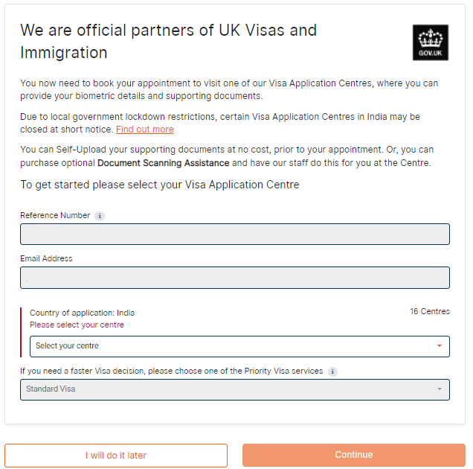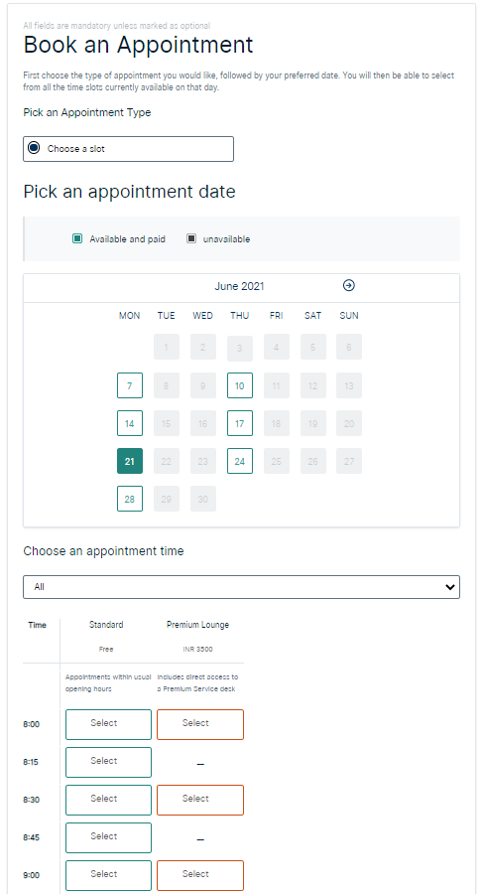
You will also need to select a date and time to attend the visa appointment. Selecting a standard appointment means that you will not need to pay any additional costs. If you wish to select the Premium Lounge option, then you will need to pay the cost of this yourself.

The next screen outlines a range of additional services that you may want to purchase to help you with your application. It is not necessary to use any of the services and you can complete your application without them. If you choose to purchase any additional services, then you will need to pay for these yourself. Different countries and different VACs offer a different variety of services. If you don’t want to purchase any additional services you can simply scroll to the bottom and select continue.
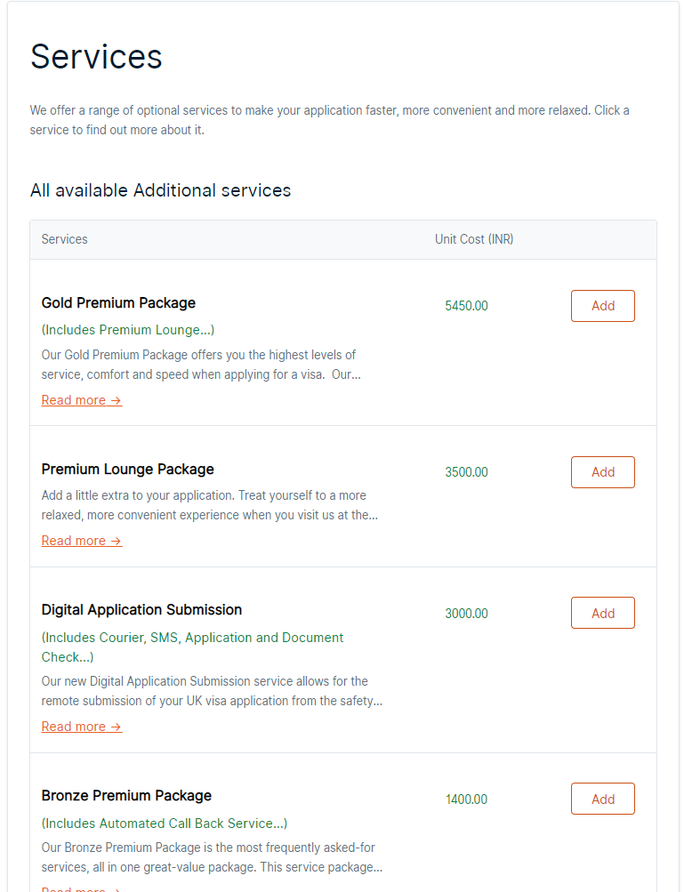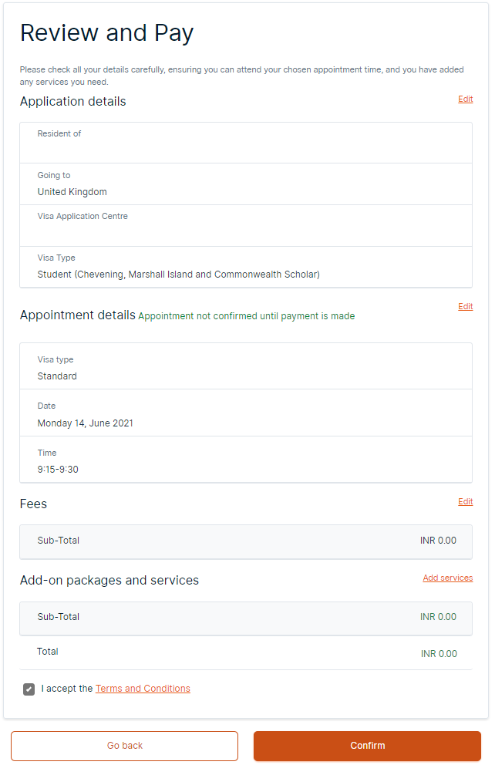
Once you have chosen any services and advanced you will be taken to a page to review your appointment and pay any fee. In certain countries, some VACs charge a mandatory fee, sometimes called a ‘user pay fee’. CSC will be able to cover the cost of this fee if it is mandatory, but will not be able to cover the cost of non-mandatory fees or additional services.

The next screen gives you another summary of your appointment booking and transaction but crucially gives you the opportunity to upload your documents via an online portal. If you do not upload the documents to the portal, you can take them in person to your visa appointment and you will need to pay a fee for the VAC staff to upload them. We will not be able to reimburse this fee.
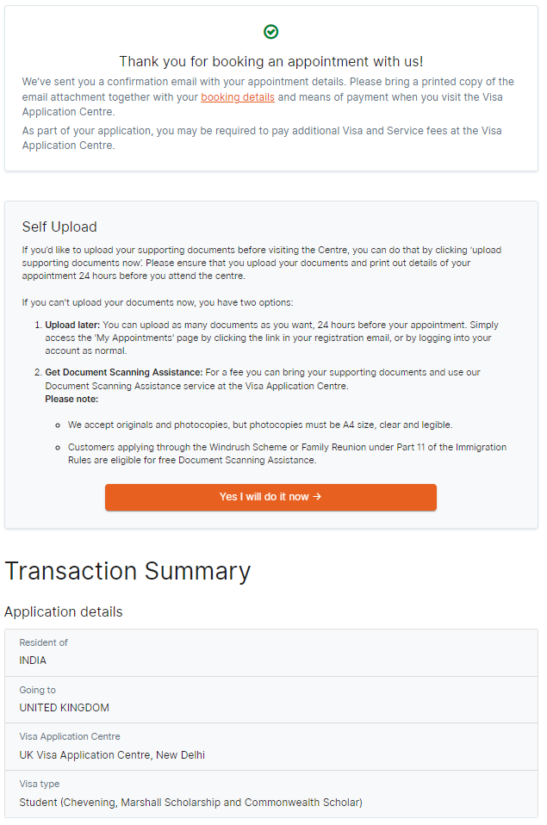
Click here to upload your documents for free.
You can upload your documents to the relevant categories shown below. You do not need to upload a document for every category, and you should only upload documents that have been asked for on the document checklist that you were required to download and print off.
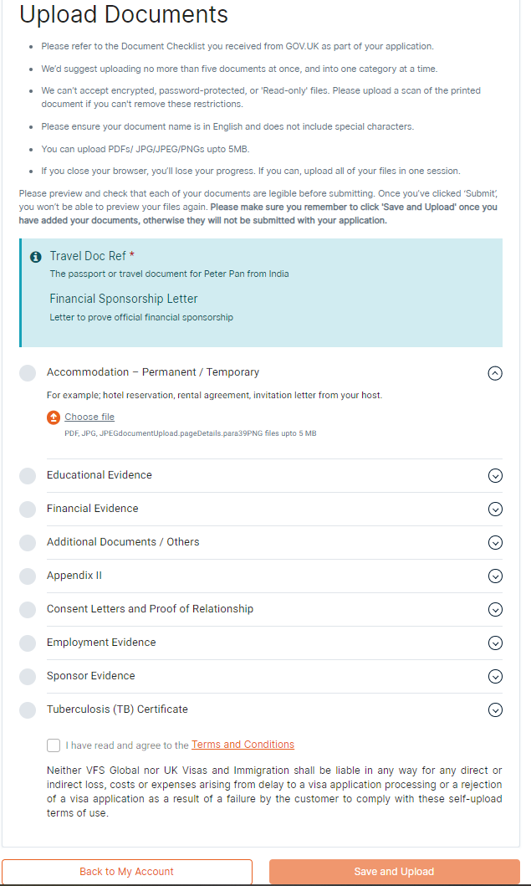
The next page provides some explanation as to what you might upload to each category.
- Accommodation – Please only use this box to upload receipts for university accommodation that you have paid for if it matches what you have completed in your application form.
- Educational Evidence – If you are not sponsored by a university with a track record of compliance or are not from a country listed in appendix H of the immigration rules you will need to provide copies of documents used to obtain your CAS. This should be noted on your CAS and may include items such as degree certificates, transcripts, or references. Please only provide the documents specifically mentioned on your CAS to this box. If you have any doubts about this section please speak with an international student adviser at your university.
- Financial Evidence – If you are required to submit financial evidence to show how you meet the financial requirements of the visa. As a CSC scholar you should not need to upload anything here. Please contact us at welfare@cscuk.org.uk if your document check list asks you to provide any financial evidence.
- Additional Documents – Please use this to upload any additional documents that are required as part of your application that does not fit another category.
- Appendix ii – Please use this for any additional or surplus documents that have been requested.
- Consent letters and proof of relationship – If you are required to submit your own financial evidence and your finances are held in an account in the name of your parent(s) or legal guardian(s) then you will need to upload proof of relationship to your parent(s) or legal guardian(s) here.
- Employment Evidence – You should not need to upload anything to this box as part of your Student application.
- Sponsor Evidence – Please use this option to upload your Confirmation of Award. Please ensure that you remove the password protection before you upload it.
- TB certificate – If you are required to provide a certificate showing that you are free of tuberculosis then please upload the document here.
IMPORTANT: It is not necessary to upload a document for every category on this screen. Please only upload documents that are requested on your supporting document checklist, and your COA if that does not appear on the checklist.

If you have not uploaded any documents, cannot upload any documents, or need assistance uploading documents you can pay for Document Scanning Assistance, which will allow you to take your documents to your appointment and the staff at the Visa Application Centre will scan the documents for you. You will be charged a fee for this service.
If you do upload your own documents, we would advise that you still take physical copies of your documents with you to your appointment. Please note, you MUST take your passport with you to your appointment.
Once you have uploaded your documents you have completed all the online elements of your visa application. You can sign out of the VFS pages at any point and log back in using your GWF number and e-mail address. You can manage your booking by changing your appointment, uploading new documents, or purchasing some additional services.
If TLS Connect are providing the Visa Application Centre services for your country, then after you have read through and accepted the terms and conditions you will see the following screens.
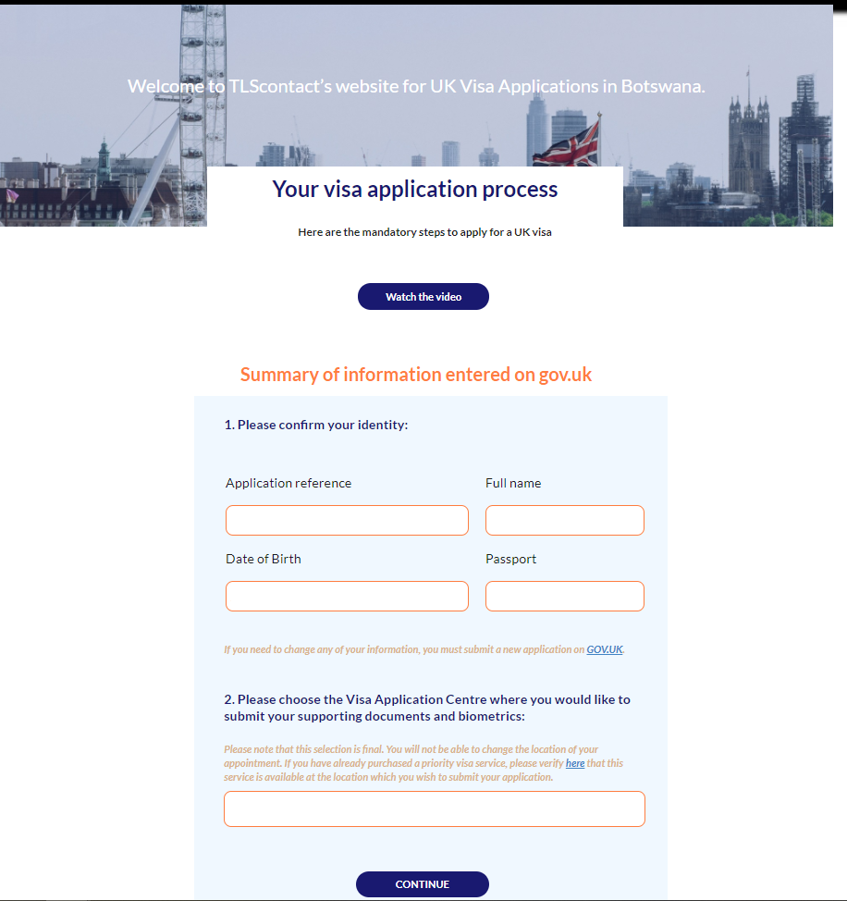
The details of your name, visa application GWF reference, date of birth and passport number should automatically be completed. The VAC where you need to attend may also be completed based on the country you put in at the start of the application. If there are mulitple cities in your country where you can attend the appointment you should be able to select this here. Note, some cities, such as larger and capital cities may have better appointment availability.
The first screen after confirming your personal details outlines a range of additional services that you may want to purchase to help you with your application. It is not necessary to use any of the services and you can complete your application without them. If you choose to purchase any additional services, then you will need to pay for these yourself. Different countries and different VACs offer a different variety of services.
Click on the green button that says ‘Step 2: Book An Appointment’ to move to the next screen to book your appointment.
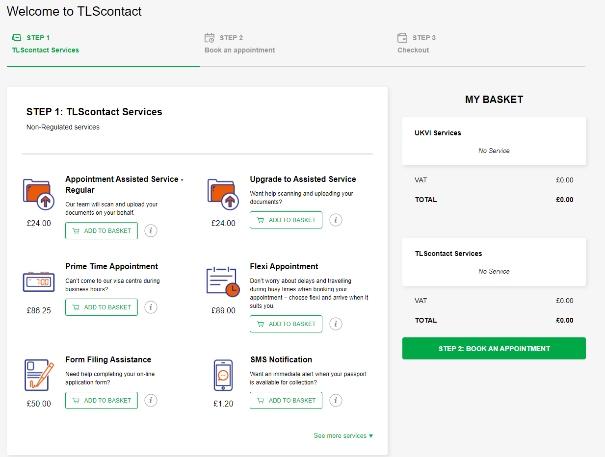

The next step requires you to book an appointment to attend the VAC and submit your biometric details. When the page first opens it will show the available appointments for Assisted Service, which you will have to pay extra for. To book a free appointment you will need to select the option for Self Service. If you use the assisted service, where the VAC staff will scan your documents for you on site you will need to pay an extra charge that you will need to cover yourself.
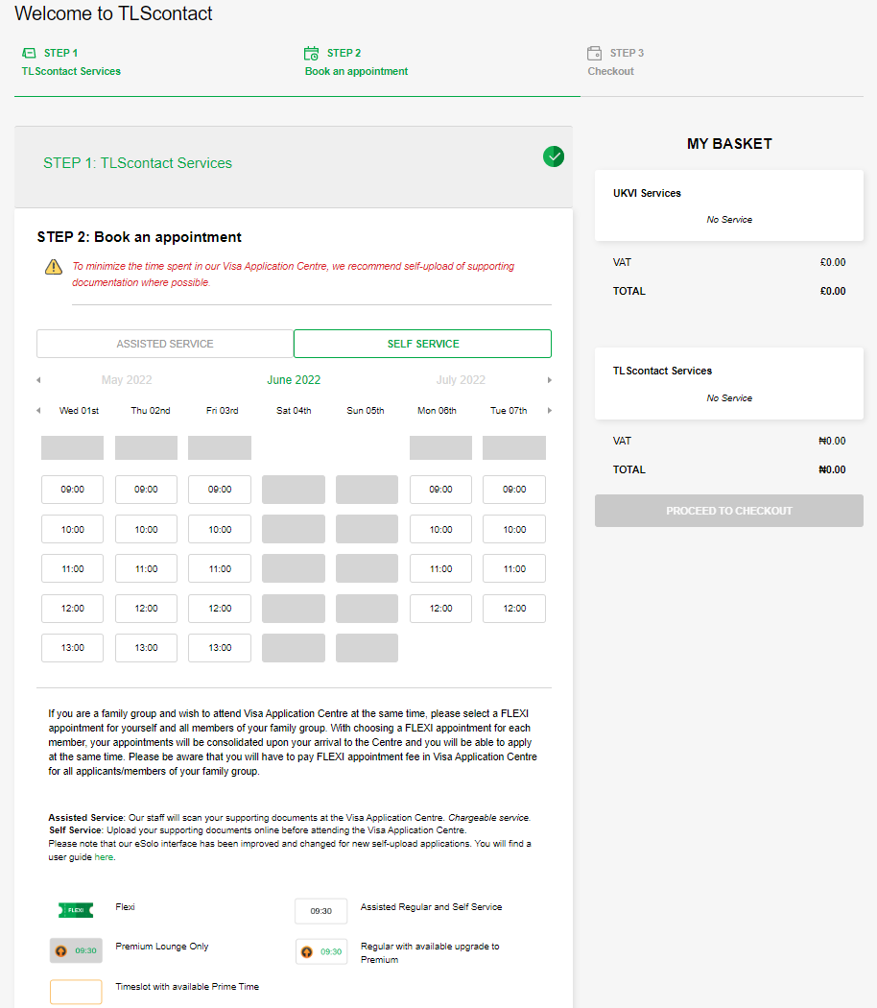
Click here to see available free appointments.
Once you have chosen your time slot you will receive confirmation of this, and you will see a button to proceed to checkout. If you have chosen self-service and no additional services, then you should not have to pay any additional fee. In certain countries, some VACs charge a mandatory fee, called a ‘user pay fee’. CSC will be able to cover the cost of this fee if it is mandatory, but will not be able to cover the cost of non-mandatory fees such as assisted service or premium appointments.
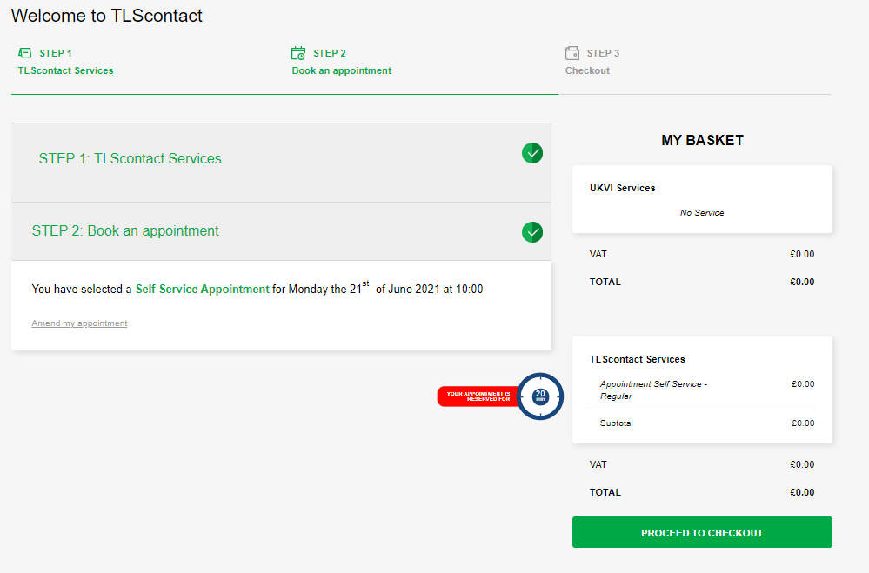
Click here to confirm your appointment booking and proceed to the next screen.
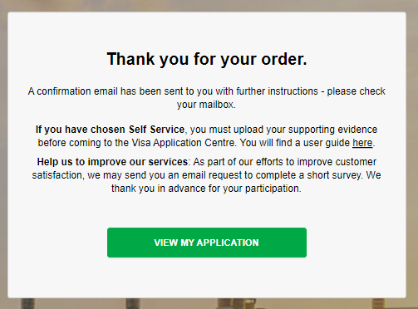
Click here to view your application and upload your documents.
This screen explains that if you have chosen self service you will need to upload your documents in advance of attending your appointment.
If you do not upload your documents in advance of attending your appointment you will need to pay a fee for a member of the VAC staff to upload the documents for you. You can do this by selecting the assisted service option when you book your appointment, as shown on the previous page.
To upload your documents, click on the View My Application Button shown on the previous screenshot. You will now see a few different headings and options. Underneath the Self-Service option please click the green upload button.
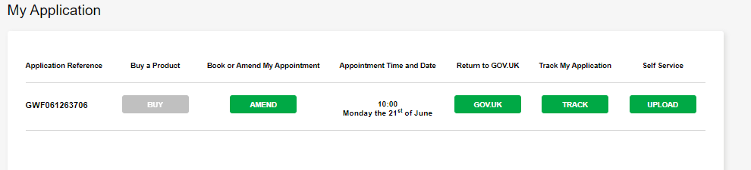
Click here to upload your documents.
You will then see the following screen where you can upload your documents.
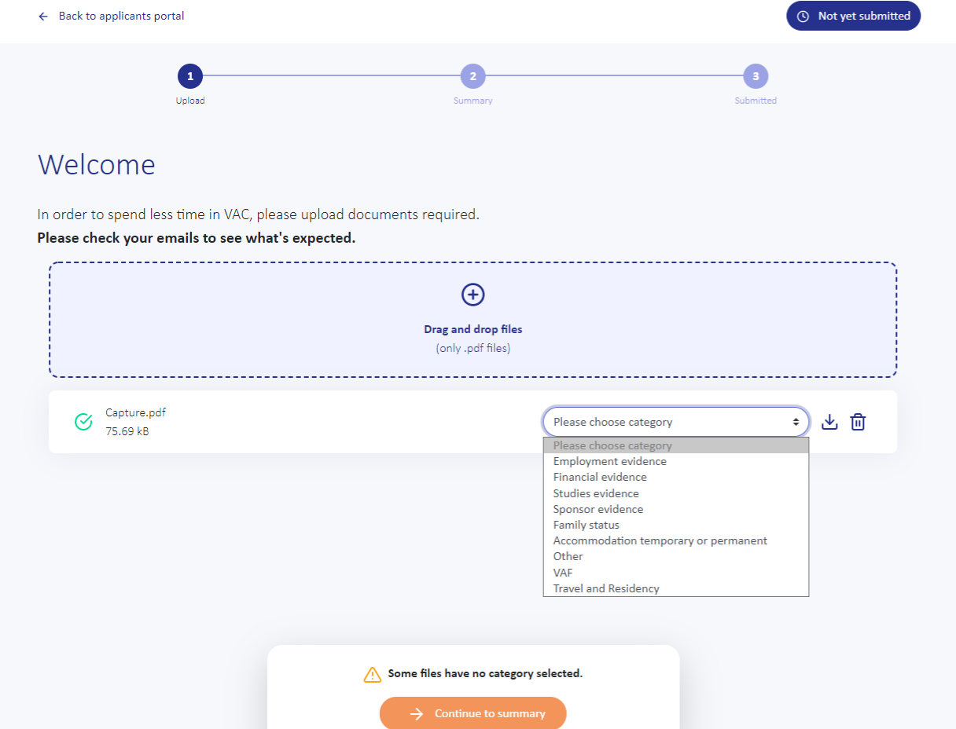
You should only upload documents that have been asked for on the document checklist that you were required to download and print off. We would recommend that you also upload your CSC Confirmation Of Award letter regardless of whether it was included in the checklist or not. For each document you upload you will need to select a category for it. Once you have uploaded all your documents you will need to ‘continue to summary’ and then press ‘submit documents’ to confirm the final submission of documents. You will not be able to submit any more documents beyond this point so please make sure you have uploaded everything you want to. You will need to take that checklist with you to your biometric appointment as well as your passport.
If you do upload your own documents, we would advise that you still take physical copies of your documents with you to your appointment. Please note, you MUST take your passport with you to your appointment.
Once you have uploaded your documents you have completed all the online elements of your visa application. You can sign out of the TLS pages at any point and log back in using your GWF number and e-mail address. You can manage your booking by changing your appointment, uploading new documents, or purchasing some additional services.

DISCLAIMER: Whilst every effort is made to ensure this guide is up to date, UKVI changes visa rules and regulations frequently. The information in this document is correct as of 24 May 2022.

